TOWN OF 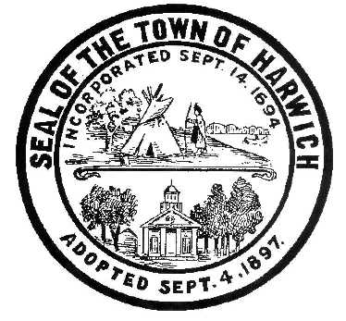 HARWICH
732 Main Street
Harwich, MA 02645
CONSERVATION COMMISSION PHONE (508)-430-7538 FAX (508)430-7531
HARWICH CONSERVATION COMMISSION - AGENDA
WEDNESDAY MARCH 18, 2020 - 6:30 P.M.
DONN B. GRIFFIN ROOM, HARWICH TOWN HALL
CALL TO ORDER
HEARINGS
***As required by Open Meeting Law, the Conservation Commission is informing the public that this meeting will be video recorded. Anyone else intending to record is required to inform the chairman prior to the meeting.
All hearings shall be subject to discussion, taking of testimony, review of submitted and documents which may result in a vote being taken to approve or deny a project; or to issue a continuance to a time and date certain in order to receive and review further information as needed.
Requests for Determinations of Applicability
Krista Plante, 12 Aaron’s Way, Map 60 Parcel G7-5. Proposed addition.
Jeffery & Karen Dunn, 49 Nons Rd, Map 5 Parcel W1-20. Deck expansion.
Moran Engineering, 113 Brooks Rd, Map 12 Parcel L4. New septic system.
Mary Jane Chase Trust, 1039 Rt 28, Map 35 Parcel S2. Confirmation of resource area delineation. Applicant has requested a continuance to April 1, 2020.
Request for Change in Plans
Eric and Reva Fischman, 39 Strandway, Map 1 Parcel J1-31A. Removal of an existing patio and construction of a new screen porch.
Notices of Intent
Christian Davenport, 0 Old Campground Rd, Map 30 Parcel C11. Construction of a duplex.
Christian Davenport, 0 Old Campground Rd, Map 30 Parcel C12. Construction of a duplex.
Vincent Helfrich, 33 Snow Inn Rd, Map 8 Parcel P3. Emergency repair to existing bulkhead.
Wychmere Harbor Club, 23 Snow Inn Rd, Map 8 Parcel P2. Emergency repairs to existing boat house & accessory structure.
Requests for Extensions
Peter & Valerie McNeely, 12 Mill Rd, Map 8 Parcel T4. Vegetation management. Request for 1-year extension.
Belmont Condominium Trust, 1 Belmont Rd, Map 1 Parcel C1-1. Beach cleaning. Request for 3-year extension
Steven Szafran, 177 Forest St, Map 31 Parcel C2. Additions and renovations. Request for 3-year extension.
Request for Certificate of Compliance
Davenport Companies, 375 Main St, Map 47 Parcel G3-3. New duplex.
Order of Conditions
Brian & Elizabeth Dolan, 3 Lincoln Ave, Map 6 Parcel G3-1. Addition, decks and mitigation plantings.
Discussion and Possible Vote
11 Harbor Way proposed helical system
51 Dunes Road Violation
39 Prince Charles Violation
Minutes August 21, 2019
Executive Session
30 Harbor Road
30/34 Lothrop Avenue
ANY OTHER BUSINESS WHICH MAY COME BEFORE THE COMMISSION
Site Visits
The Conservation Commission will meet at Town Hall at 2:00 p.m. to proceed to site visits.
Authorized posting officer: Posted by: Town Clerk
Nicole Smith_
Signature Date: 3/12/2020

