TOWN OF 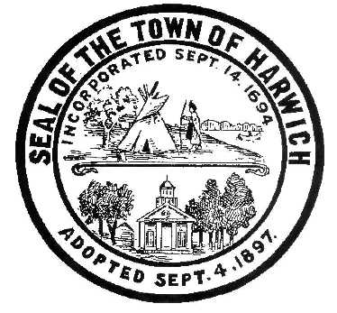 HARWICH
732 Main Street
Harwich, MA 02645
PHONE (508)-430-7538 FAX (508)430-7531
HARWICH CONSERVATION COMMISSION - MEETING AGENDA
TOWN HALL - GRIFFIN ROOM
WEDNESDAY – MARCH 15, 2023 – 6:30 PM

*Public may attend the meeting in person, access the meeting on Channel 18 (Broadcasting Live), or can login to the meeting remotely using the following login information*
Please join my meeting from your computer, tablet or smartphone.
https://meet.goto.com/838495669
You can also dial in using your phone.
Access Code: 838-495-669
United States: +1 (571) 317-3112

New to GoToMeeting? Download the App here: https://meet.goto.com/install

6:30 PM HEARINGS
All hearings shall be subject to discussion, taking of testimony, review of submitted and documents which may result in a vote being taken to approve or deny a project; or to issue a continuance to a time and date certain in order to receive and review further information as needed.
Presentation and Possible Vote:
Citizen Petition for May Town Meeting by resident Patrick Otton for a potential Fertilizer Ban

The following applicants have filed for a Request for a Change in Plan

Michael Lach, Harwich Conservation Trust, Cold Brook Preserve, Map 23 Parcels C3-2, C1-0, and C1-1. SE32-2505. Changes related to the on-site reuse of excavated material.

Paul and Susan Cicco, 45 Neel Rd, Map 16 Parcel N1-41. RDA 2022-10. Reconfiguration of approved addition, pool, and hardscape.

The following applicants have filed a Notice of Intent
Peter Van Dyck & Ann Foster, 5 Panorama Point Dr, Map 91 Parcel G2-7. Access Stairs and Seasonal Dock.

Enforcement Orders
117 & 123 Riverside Dr – Review and possible vote on proposed restoration plan

Discussion and Possible Vote
Natalia Wallace, 16 Olde Coach Ln, Map 112 Parcel A6-28. SE32-2527. Applicant has requested a continuation of the discussion from the March 1, 2023 meeting for potential design changes.

Orders of Conditions
Natalia Wallace, 16 Olde Coach Ln, Map 112 Parcel A6-28. SE32-2527. Restoration Plan and after-the-fact application to permit Deck Expansion.

Donald Annino, 14 Mill Point Rd, Map 1 Parcel J1-94. SE32-2494. Proposed Pier, Ramp, Float, and Dredging.

William Beekman, 194 John Joseph Rd, Map 72 Parcel G1-2. SE32-2522. Construction of Retaining Walls, Reconstruction of Patio and Deck, and Site Improvements.

Robert and Paula Bigelow Howard, 7 Nons Rd, Map 6 Parcel C1-9. SE32-2524. Increase Float Size.

10 Harbor Rd LLC, 10 Harbor Rd, Map 8 Parcel S1-0. SE32-2519. Removal and Reconstruction of Single Family Dwelling and Site Improvements.

Discussion and Possible Vote:
Update of Harwich Wetlands Protection Regulations

Update on ongoing land management tasks:
Herring River Study

Minutes
October 19, 2022
November 2, 2022
November 16, 2022

ANY OTHER BUSINESS WHICH MAY COME BEFORE THE COMMISSION
Authorized posting officer: Posted by: Town Clerk
Melyssa Millett
Signature Date:

