TOWN OF 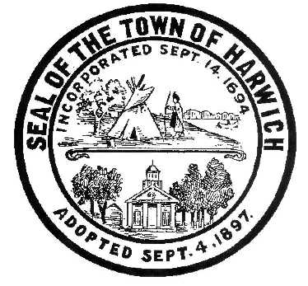 HARWICH
732 Main Street
Harwich, MA 02645
PHONE (508)-430-7538 FAX (508)430-7531
HARWICH CONSERVATION COMMISSION - MEETING AGENDA
TOWN HALL - GRIFFIN ROOM
WEDNESDAY – MARCH 1, 2023 – 6:30 PM
*Public may attend the meeting in person, access the meeting on Channel 18 (Broadcasting Live), or can login to the meeting remotely using the following login information*

Please join my meeting from your computer, tablet or smartphone.
https://meet.goto.com/922369709
You can also dial in using your phone.
Access Code: 922-369-709
United States: +1 (872) 240-3212

New to GoToMeeting? Download the App here: https://meet.goto.com/install
6:30 PM HEARINGS
All hearings shall be subject to discussion, taking of testimony, review of submitted and documents which may result in a vote being taken to approve or deny a project; or to issue a continuance to a time and date certain in order to receive and review further information as needed.
The following applicants have filed a Notice of Intent
Donald Annino, 14 Mill Point Rd, Map 1 Parcel J1-94. Proposed Pier, Ramp, Float, and Dredging.

Thomas and Gina Flannery, 58 Chase St, Map 4 Parcel E2-B. Replace Bulkhead.

William Beekman, 194 John Joseph Rd, Map 72 Parcel G1-2. Construction of Retaining Walls, Reconstruction of Patio and Deck, and Site Improvements.

Robert and Paula Bigelow Howard, 7 Nons Rd, Map 6 Parcel C1-9. Increase Float Size.

10 Harbor Rd LLC, 10 Harbor Rd, Map 8 Parcel S1-0. Removal and Reconstruction of Single Family Dwelling and Site Improvements.

Natalia Wallace, 16 Olde Coach Ln, Map 112 Parcel A6-28. Restoration Plan and after-the-fact application to permit Deck Expansion.

Enforcement Orders
117 & 123 Riverside Dr – Review of proposed restoration plan

15 & 19 Shore Rd – Review of proposed restoration plan

Discussion and Possible Vote
As-Built Road Plan for Chloe’s Path

Orders of Conditions
John Leong and Charis Cladouhos, 25 Trout Brook & 27 Sound View Rd, Map 26 Parcels C1-6 & L1-9. SE32-2523. Construct Reinforcing Retaining Wall.

Pleasant Bay Community Boating, 2285 & 2287 Rte 28 – Head of the Bay Rd, Map 119 Parcels N7-3 & N8-0. SE32-2518. Changes to parking areas, retaining walls, walkways, stairs, and deck.

Round Cove Resort Owner LLC, 2173 Rt 28 – Head of the Bay Rd & 4 Cove Landing Rd, Map 115 Parcels S1-3 & R2. SE32-2521. Raze and Replace Buildings A, B, and K, Planting, and Hardscape Improvements.

HFH Development, (4, 8, 11, 12, 16, 17, 20) Chloe’s Path & 0 Forest St, Map 31 Parcels D4-3, D4-4, D4-5, D4-6, D4-7, D4-8, D-4-9, & D3. SE32-2519. Re-establishment of the turtle protection plan set forth in NHESP 09-20086.

Wychmere Harbor Real Estate LLC, 23 Snow Inn Rd, Map 8 Parcel P2. NHESP File #11-29126. Amendment to SE32-2387. Reconfiguration of beach grass mitigation area, and incorporation of HCP filed with NHESP.

Discussion and Possible Vote:
Update on ongoing land management tasks:
Herring River Study

Minutes
September 21, 2022
October 5, 2022
February 24, 2023

ANY OTHER BUSINESS WHICH MAY COME BEFORE THE COMMISSION
Authorized posting officer: Posted by: Town Clerk
Melyssa Millett
Signature Date:

