TOWN OF 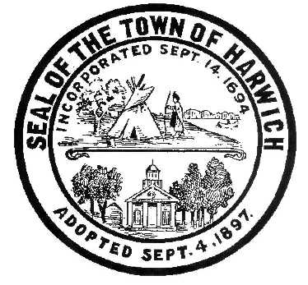 HARWICH
732 Main Street
Harwich, MA 02645
CONSERVATION COMMISSION
PHONE (508)-430-7538 FAX (508)430-7531
HARWICH CONSERVATION COMMISSION - AGENDA
REMOTE - MARCH 30, 2022 - 6:00 PM
*Public may attend the meeting in person, access the meeting on Channel 18 (Broadcasting Live), or can login to the meeting remotely using the following login information*
Please join my meeting from your computer, tablet or smartphone.
https://meet.goto.com/863143853
You can also dial in using your phone.
United States: +1 (312) 757-3121
Access Code: 863-143-853
New to GoToMeeting? Download the App here: https://meet.goto.com/install
6:00 PM MEETING
Discussion and vote on the proposed changes to the Harwich Water Dependent Structures Bylaw Chapter 304 for the Warrant for the May 2022 Town Meeting.

Authorized posting officer: Posted by: Town Clerk
Melyssa Millett
Signature Date: 3/25/2022

