TOWN OF 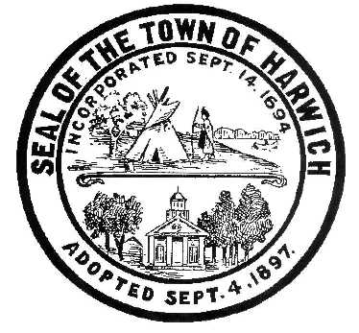 HARWICH
732 Main Street
Harwich, MA 02645
CONSERVATION COMMISSION
PHONE (508)-430-7538 FAX (508)430-7531
HARWICH CONSERVATION COMMISSION - AGENDA
WEDNESDAY MAY 19, 2021 6:30 PM
REMOTE PARTICIPATION

*Public can access the meeting on Channel 18 (Broadcasting Live)*
Pursuant to Governor Baker’s March 12, 2020 Order Suspending Certain Provisions of the Open Meeting Law, G.L. c. 30A, §18, and the Governor’s March 15, 2020 Order imposing strict limitation on the number of people that may gather in one place, this meeting of the Town of Harwich Conservation Commission on May 19, 2021 at 6:30 p.m. will be conducted via remote participation. Specific information and the general guidelines for remote participation by members of the public and/or parties with a right and/or requirement to attend this meeting can be found on the Town of Harwich website, at www.harwich-ma.gov. For this meeting, members of the public who wish to watch the meeting may do so via a recording On Demand on the Harwich Channel 18 website, or on our Town of Harwich YouTube page.
Please join my meeting from your computer, tablet or smartphone.
https://global.gotomeeting.com/join/258246813
You can also dial in using your phone.
United States: +1 (872) 240-3412
Access Code: 258-246-813

CALL TO ORDER
HEARINGS
All hearings shall be subject to discussion, taking of testimony, review of submitted and documents which may result in a vote being taken to approve or deny a project; or to issue a continuance to a time and date certain in order to receive and review further information as needed.
The following applicants have filed a Notice of Intent:

John Walsh, 5 Sea St, Map 7 Parcel D22. New dwelling.

The following applicants have requested to Amend an Order of Conditions:

Mark Kelleher, Kelpeher Farms, Nantucket Sound. Request to Amend Order of Conditions SE32-2346 with the addition of bay scallops to sugar kelp line.

Paul Vasil, 15 Doane Rd, Map 13 Parcel E3-1. Request to Amend Order of Conditions SE32-2388 with change of 12’x20’ deck to 24’x30’ pervious patio.

The following applicants have filed a Notice of Intent:

Alfred & Carol Novak, 30 Harbor Rd, Map 15 Parcel 15-A. Dock.

Lee Colton & Nan White, 0 Old Campground Rd, Map 30 Parcels C6, C7, C8 & C9. New dwelling.

Robert & Kalliope Badavas, 31 Mill Rd, Map 15 Parcel U3. Pool, hardscape, and planting.

David & Beverly Canavan, 176 Gorham Rd, Map 24 Parcel P4-1. Pool, hardscape, and planting.

Paul & Diane Manning, 16 Harbor Rd, Map 8 Parcel S2. Maintenance Dredging and additional fender piles.

Michael & Sheila LeBlanc, 28 Wah Wah Taysee Rd, Map 6 Parcel F1-12. Proposed elevated walkway and landing. Have requested a Continuance.

ANY OTHER BUSINESS WHICH MAY COME BEFORE THE COMMISSION
Authorized posting officer: Posted by: Town Clerk
Melyssa Millett
Signature Date: 5/12/21

