TOWN OF 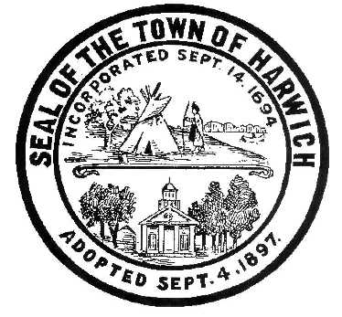 HARWICH
732 Main Street
Harwich, MA 02645
CONSERVATION COMMISSION PHONE (508)-430-7538 FAX (508)430-7531
HARWICH CONSERVATION COMMISSION - AGENDA
WEDNESDAY MAY 21, 2020 - 6:30 P.M.

REMOTE PARTICIPATION
*Public can access the meeting on Channel 18 (Broadcasting Live)*
Conservation Commission - Thursday, May 21, 2020 @6:30 PM
Thu, May 21, 2020 6:30 PM - 9:30 PM (EDT)
Please join my meeting from your computer, tablet or smartphone.
https://global.gotomeeting.com/join/380629245
You can also dial in using your phone.
United States: +1 (669) 224-3412
Access Code: 380-629-245
Pursuant to Governor Baker’s March 12, 2020 Order Suspending Certain Provisions of the Open Meeting Law, G.L. c. 30A, §18, and the Governor’s March 15, 2020 Order imposing strict limitation on the number of people that may gather in one place, this meeting of the Town of Harwich Conservation Commission on May 21, 2020 at 6:30 p.m. will be conducted via remote participation. Specific information and the general guidelines for remote participation by members of the public and/or parties with a right and/or requirement to attend this meeting can be found on the Town of Harwich website, at www.harwich-ma.gov. For this meeting, members of the public who wish to watch the meeting may do so via a recording On Demand on the Harwich Channel 18 website, or on our Town of Harwich YouTube page:
https://www.youtube.com/user/HarwichChannel18/videos?disable_polymer=1

No in-person attendance of members of the public, staff, or commissioners will be permitted, but every effort will be made to ensure that the public can adequately access the proceedings in real time, via technological means. In the event that we are unable to do so, despite best efforts, we will post on the Town of Harwich’s website an audio or video recording, transcript, or other comprehensive record of proceedings as soon as possible after the meeting.

CALL TO ORDER
HEARINGS
All hearings shall be subject to discussion, taking of testimony, review of submitted and documents which may result in a vote being taken to approve or deny a project; or to issue a continuance to a time and date certain in order to receive and review further information as needed.
Requests for Determination of Applicability
Mike and Beth Adams, 97 Pleasant Road, Map Parcel Z3-5. Enlarge Driveway.
Amended Order of Conditions
Vincent Helfrich, 33 Snow Inn Road, Map 8 Parcel P3-0. Proposed dead man tie back system and access improvements.
Notices of Intent
G. Rockwood Clark, 220 Long Pond Road, Map 102 Parcel K2. Remove walkway, steps, and retaining wall. Construct new walkway, landing, stairs, and stone wall. Plant area of erosion.
Extension Request
Rocco Orsini, 56 Purmackene Ln, Map 24 Parcel H17. Dwelling.
Discussion and Possible Vote
Management Plan for the Bogs at the Bells Neck Conservation Area
Plover Update
Minutes April 15, 2020
ANY OTHER BUSINESS WHICH MAY COME BEFORE THE COMMISSION
Authorized posting officer: Posted by: Town Clerk
Amy Usowski_
Signature Date: 5/15/2020

