TOWN OF 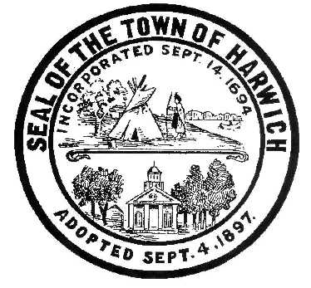 HARWICH
732 Main Street
Harwich, MA 02645
CONSERVATION COMMISSION
PHONE (508)-430-7538 FAX (508)430-7531
HARWICH CONSERVATION COMMISSION - AGENDA
TOWN HALL - GRIFFIN ROOM
MAY 4, 2022 – 5:30 PM
*Public may attend the meeting in person, access the meeting on Channel 18 (Broadcasting Live), or can login to the meeting remotely using the following login information*
Please join my meeting from your computer, tablet or smartphone.
https://meet.goto.com/142991365
You can also dial in using your phone.
United States: +1 (571) 317-3122
Access Code: 142-991-365
New to GoToMeeting? Download the App here: https://meet.goto.com/install
HEARINGS
All hearings shall be subject to discussion, taking of testimony, review of submitted and documents which may result in a vote being taken to approve or deny a project; or to issue a continuance to a time and date certain in order to receive and review further information as needed.
Public Hearing
374 Main St – Discussion and possible vote regarding the management of the bogs and land at 374 Main St, and the potential Inter-Municipal Agreement between the Town of Harwich and Cape Cod Regional Technical High School.
The following applicants have filed an Abbreviated Notice of Resource Area Delineation
Paul and Susan Cicco, 45 Neel Rd, Map 16 Parcel N1-41. Proposed Resource Area and Buffer Zone Delineation.

The following applicants have filed a Request for a Determination of Applicability
Joel and Lisa Winer, 51 Deep Hole Rd, Map 17 Parcel A1-40. Install patio and stepping stones, and reconfigure driveway.

Tadry Domagala, 2 Harvest Hollow Rd, Map 23 Parcel C4-2. Deck expansion.

The following applicants have filed a Notice of Intent
Stephen & Linda Bonica, 4 Salt River Ln, Map 4 Parcel A1-B2. Deck expansion, gravel walkway, and planting.

Catherine Shanahan, 47 Saquatucket Bluffs Rd, Map 9 Parcel A1-3. Beach access stairs.

Donald Annino, 14 Mill Point Rd, Map 1 Parcel J1-94. Proposed Pier, Ramp, Float, and Dredging.

Oliver Cox, 7 Skecheconet Way, Map 4 Parcel C1-4. Proposed Pier, Ramp, Float, and Bank Stabilization.

Discussion and Possible Vote
Violation – 4 Braddock St - Snow Fencing to be removed April 1-August 31 per SE32-2451.

Orders of Conditions:
Wychmere Harbor Real Estate LLC., 23 Snow Inn Road, Map 8 Parcel P2-0. Installation of additional synthetic turf at the Wychmere Beach Club in place of the ‘natural’ lawn that was previously approved, and associated mitigation work.

Kathleen & William Lockyer, 280 Bank St, Map 32 Parcel A2-5. Pool and Walkway.

Bruce Soderholm, 27 Seventh St, Map 101 Parcel X3. Alter garage, upgrade septic, and appurtenances.

William & Tracy Gibson, 14 Sequattom Rd, Map 101 Parcel R3. Seasonal Dock.

The following applicants have filed a Request for a Certificate of Compliance
Richard and Barbara Concordia, 754 Route 28, Map 24 Parcel S1. SE32-1521. Garage/storage building.

Minutes
March 4, 2020
March 2, 2022
March 16, 2022
April 20, 2022

ANY OTHER BUSINESS WHICH MAY COME BEFORE THE COMMISSION
Authorized posting officer: Posted by: Town Clerk
Melyssa Millett
Signature Date: 4/29/2022 __________

