TOWN OF 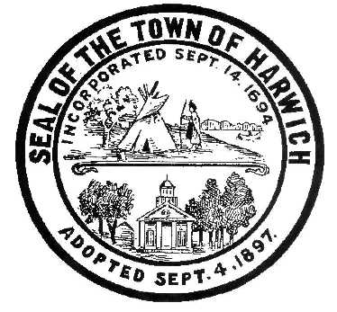 HARWICH
732 Main Street
Harwich, MA 02645
CONSERVATION COMMISSION
PHONE (508)-430-7538 FAX (508)430-7531
HARWICH CONSERVATION COMMISSION - AGENDA
TOWN HALL - GRIFFIN ROOM - NOVEMBER 17, 2021
Executive Session – 6:00 PM
Regular Session - 6:30 PM

*Public may attend the meeting in person, access the meeting on Channel 18 (Broadcasting Live), or can login to the meeting remotely using the following login information*

Please join my meeting from your computer, tablet or smartphone.
https://global.gotomeeting.com/join/138073029
You can also dial in using your phone.
United States: +1 (872) 240-3412
Access Code: 138-073-029
New to GoToMeeting? Get the app now and be ready when your first meeting starts: https://global.gotomeeting.com/install/138073029

6:00 PM EXECUTIVE SESSION
Update and possible vote on various court cases:
Walsh Brothers Building Company, Inc., et al. v. Harwich Conservation Commission, and Town of Harwich
King and James M. Kelly v. Harwich Conservation Commission
King and Kelly v. Walter Diggs et al. and the Harwich Conservation Commission,
Novak v. Town of Harwich Conservation Commission
Stevens Wequassett Trust v. Harwich Conservation Commission
Viprino v. Town of Harwich

6:30 PM HEARINGS
All hearings shall be subject to discussion, taking of testimony, review of submitted and documents which may result in a vote being taken to approve or deny a project; or to issue a continuance to a time and date certain in order to receive and review further information as needed.

The following applicants have filed a Request for Determination of Applicability
Frank & Gale Vitale, 5 Lynch Ln, Map 65 Parcel N5-5. Proposed addition, deck, and septic replacement.

James Sullivan, 6 Brora Dr, Map 15 Parcel U2-2. Proposed addition and septic relocation.

Clark & Jen Lord, 14 Fairview Ave, Map 48 Parcel N5-9. Access steps to pond and shed replacement/relocation.

The following applicants have filed a Notice of Intent
Brian Hellauer, 4 Shady Dr, Map 73 Parcel X180. New dwelling and appurtenances.

Wesley Price, 0 Clearwater Dr, Map 73 Parcels P94 & P95. New dwelling and appurtenances.

Orders of Conditions
Paul Vasil, 15 Doane Rd, Map 13 Parcel E3-1. Amend Order of Conditions SE32-2388 for 190sf increase in patio size with proposed mitigation.

Jeff Lang, 99 Riverside Dr, Map 4 Parcel A3-A1. Amend Order of Conditions SE32-2355 for 2 years to complete the required restoration and mitigation plantings, and remove various trees on the property with additional proposed mitigation.

The following applicants have requested a Certificate of Compliance
Arthur Crooks, 24 Wychmere Harbor Dr, Map 15 Parcel E4-6. SE32-504. Originally Lot 6. New dwelling with deck and septic.

William and Judith Barnatt, 24 Wychmere Harbor Dr, Map 15 Parcel E4-6. SE32-2340. Invasive management and replacement of on-grade wooden stairs.

Minutes
August 18, 2021
September 1, 2021
September 15, 2021

Discussion and Possible Vote
Proposed changes to the draft Harwich Wetlands Protection Bylaw
Approval of 2022 Meeting Dates

ANY OTHER BUSINESS WHICH MAY COME BEFORE THE COMMISSION
Authorized posting officer: Posted by: Town Clerk
Melyssa Millett
Signature Date: 11/12/21

