TOWN OF 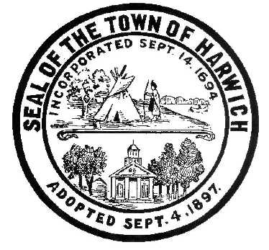 HARWICH
732 Main Street
Harwich, MA 02645
CONSERVATION COMMISSION
PHONE (508)-430-7538 FAX (508)430-7531
HARWICH CONSERVATION COMMISSION - AGENDA
TOWN HALL - GRIFFIN ROOM - NOVEMBER 3, 2021
Executive Session – 6:00 PM
Regular Session - 6:30 PM
REVISED

*Public may attend the meeting in person, access the meeting on Channel 18 (Broadcasting Live), or can login to the meeting remotely using the following login information*

Please join my meeting from your computer, tablet or smartphone.
https://global.gotomeeting.com/join/322266477
You can also dial in using your phone.
United States: +1 (224) 501-3412
Access Code: 322-266-477
New to GoToMeeting? Get the app now and be ready when your first meeting starts: https://global.gotomeeting.com/install/322266477

6:00 PM EXECUTIVE SESSION
- Real Estate and Open Space Committee’s request for a letter of support for the town to acquire land in East Harwich for Open Space Preservation.
- Update on various court cases: Stevens Wequasset Trust vs. Harwich Conservation Commission, Estate of Lois Jones vs. Harwich Conservation Commission, King vs. Harwich Conservation Commission, and Viprino vs. Harwich Conservation Commission.
6:30 PM HEARINGS
All hearings shall be subject to discussion, taking of testimony, review of submitted and documents which may result in a vote being taken to approve or deny a project; or to issue a continuance to a time and date certain in order to receive and review further information as needed.
The following applicants have filed a Request for Determination of Applicability
Robbin Kelley, 15 Island Pond Rd, Map 40 Parcel V3. Vegetation management around lily pond.

Thomas and Elaine Monahan, 8 Sea Way, Map 2 Parcel A1-64. Remove existing dwelling and appurtenances, and construct new dwelling with associated hardscape and septic.

The following applicants have requested to Amend and Order of Conditions
Paul Vasil, 15 Doane Rd, Map 13 Parcel E3-1. After-the-fact request to Amend Order of Conditions SE32-2388 for 190sf increase in patio size with proposed mitigation.

Jeff Lang, 99 Riverside Dr, Map 4 Parcel A3-A1. Request to Extend and Amend Order of Conditions SE32-2355 for 2 years to complete the required restoration and mitigation plantings, and remove various trees on the property with additional proposed mitigation.

The following applicants have filed a Notice of Intent
Kerry Sullivan, 123 Riverside Dr, Map 4 Parcel A1-A10. Proposed pool, outbuilding, patio, and landscaping.

Virginia Nabors, 48 North Rd, Map 11 Parcel A1. Proposed Bulkhead and Fiber Rolls.

Orders of Conditions
Dana Elliot, 2 Harwich Pines, Map 103 Parcel S1A-9. Septic Installation.

Bob and Sheera Knecht, 86 Squantos Path, Map 100 Parcel G1-2. Extension of existing deck with rinse station, landscaping, kayak rack, and replacement of stairs.

Jeff Handler, 397 Route 28, Map 13 Parcel D1. Amendment to SE32-2424 for Emergency building removal.

The following applicants have requested an Extension
Keith O’Donnell, 55 Sugar Hill Dr, Map 88 Parcel R49. SE32-2166. Upgrade of existing cesspools to Title 5 Septic.

Minutes
June 2, 2021
August 18, 2021
October 21, 2021 On-Site

Discussion and Possible Vote
Phragmites Management at Bells Neck Bogs
Proposed changes to the draft Harwich Wetlands Protection Bylaw

ANY OTHER BUSINESS WHICH MAY COME BEFORE THE COMMISSION
Authorized posting officer: Posted by: Town Clerk
Melyssa Millett
Signature Date: 10/29/21

