TOWN OF 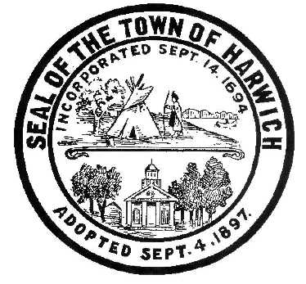 HARWICH
732 Main Street
Harwich, MA 02645
CONSERVATION COMMISSION
PHONE (508)-430-7538 FAX (508)430-7531
HARWICH CONSERVATION COMMISSION - AGENDA
GRIFFIN ROOM – TOWN HALL
OCTOBER 20, 2021 – 6:30 PM
REVISED

*Public may attend the meeting in person, access the meeting on Channel 18 (Broadcasting Live), or can login to the meeting remotely using the following login information*

Please join my meeting from your computer, tablet or smartphone.
https://global.gotomeeting.com/join/867107125
You can also dial in using your phone.
United States: +1 (786) 535-3211
Access Code: 867-107-125
New to GoToMeeting? Get the app now and be ready when your first meeting starts: https://global.gotomeeting.com/install/867107125

6:30 PM HEARINGS
All hearings shall be subject to discussion, taking of testimony, review of submitted and documents which may result in a vote being taken to approve or deny a project; or to issue a continuance to a time and date certain in order to receive and review further information as needed.
For Discussion and Vote

The Harwich Fire Department has requested to use Thompson’s Field Conservation Area for the Barnstable County Tech rescue team drill in November.

The following applicants have filed a Request for Determination of Applicability

Robbin Kelley, 15 Island Pond Rd, Map 40 Parcel V3. Vegetation management around lily pond.

Robbin Kelley, 15 Island Pond Rd, Map 40 Parcel V3. New access path to Island Pond Trails and install split-rail fence around proposed parking area.

Daniel Pettengill, 49 Saquatucket Bluffs Rd, Map 8 Parcel G1-4. After-the-fact dwelling addition.

Clifford Connell, 81 Route 28, Map 10 Parcel W2-2. Emergency septic replacement.

The following applicants have requested to Amend and Order of Conditions

Jeff Handler, 397 Route 28, Map 13 Parcel D1. SE32-2424. Emergency building removal.

The following applicants have filed a Notice of Intent

Dana Elliot, 2 Harwich Pines, Map 103 Parcel S1A-9. Septic Installation.

Bob and Sheera Knecht, 86 Squantos Path, Map 100 Parcel G1-2. Extension of existing deck with rinse station, landscaping, kayak rack, and replacement of stairs.

Kerry Sullivan, 123 Riverside Dr, Map 4 Parcel A1-A10. Proposed pool, outbuilding, patio, and landscaping.

Wesley Price, 0 Clearwater Dr, Map 73 Parcels P94 & P95. New dwelling and appurtenances.

Brian Hellauer, 4 Shady Dr, Map 73 Parcel X180. New dwelling and appurtenances.

Order of Conditions

George Seiler, 25 Belle Brook Rd, Map 23 Parcel X6. Demo and rebuild house, septic, and appurtenances.

David Scott Sloan, 49 Snow Inn Rd, Map 15 Parcel N2. Reconstruction of existing pier, ramp and float and dredging.

William Ebben, 0 Snow Inn Rd, Map 15 Parcel N8-B. Proposed pier, ramp, float, and dredging.

The following applicants have requested an Extension

Keith O’Donnell, 55 Sugar Hill Dr, Map 88 Parcel R49. SE32-2166. Upgrade of existing cesspools to Title 5 Septic.

The following applicants have requested a Certificate of Compliance

Frank & Elaine Sampson, 109 Riverside Drive, Map 4 Parcel A3-A2. SE32-1053. Alteration and maintenance of an existing pier.

Frank & Elaine Sampson, 109 Riverside Drive, Map 4 Parcel A3-A2. SE32-1045. Removal and reconstruction of a SF dwelling and septic system.

Minutes

June 2, 2021
August 18, 2021

ANY OTHER BUSINESS WHICH MAY COME BEFORE THE COMMISSION
Authorized posting officer: Posted by: Town Clerk
Melyssa Millett
Signature Date: 10/15/21

