TOWN OF 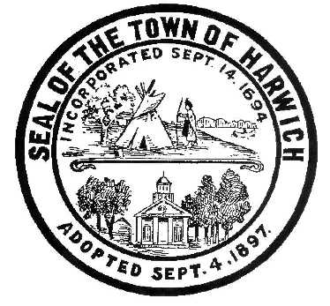 HARWICH
732 Main Street
Harwich, MA 02645

CONSERVATION COMMISSION
PHONE (508)-430-7538 FAX (508)430-7531
HARWICH CONSERVATION COMMISSION - AGENDA
GRIFFIN ROOM – TOWN HALL
OCTOBER 6, 2021 – 6:30 PM

*Public may attend the meeting in person, access the meeting on Channel 18 (Broadcasting Live), or can login to the meeting remotely using the following login information*

Please join my meeting from your computer, tablet or smartphone.
https://global.gotomeeting.com/join/753986189

You can also dial in using your phone.
United States: +1 (408) 650-3123
Access Code: 753-986-189

New to GoToMeeting? Get the app now and be ready when your first meeting starts: https://global.gotomeeting.com/install/753986189

6:30 PM HEARINGS
All hearings shall be subject to discussion, taking of testimony, review of submitted and documents which may result in a vote being taken to approve or deny a project; or to issue a continuance to a time and date certain in order to receive and review further information as needed.
The following applicants have filed a Request for Determination of Applicability

Ann Harrington, 87 Punkhorn Rd, Map 100 Parcel A6. New foundation under existing dwelling.

Kenyon Keyes, 6 Meadowbrook Ln, Map 32 Parcel X1-7. Repair of garage wall.

The following applicants have filed a Notice of Intent

Bob and Sheera Knecht, 86 Squantos Path, Map 100 Parcel G1-2. Extension of existing deck with rinse station, landscaping, kayak rack, and replacement of stairs.

George Seiler, 25 Belle Brook Rd, Map 23 Parcel X6. Demo and rebuild house, septic, and appurtenances.

David Scott Sloan, 49 Snow Inn Rd, Map 15 Parcel N2. Reconstruction of existing pier, ramp and float and dredging.

William Ebben, 0 Snow Inn Rd, Map 15 Parcel N8-B. Proposed pier, ramp, float, and dredging.

Mark and Debra Ellis, 23 Mill Rd, Map 15 Parcel U4-32. Proposed access steps, elevated walkway, and vista management.

Certificates of Compliance
John and Geraldine McGrann, 356 Lower County Road, Map 13 Parcel V4, SE32-707.
Permit was to add a deck to an existing home.

Discussion and Possible Vote
Update and possible vote on violations at 52 and 47 North Road

Minutes
March 17, 2021
April 7, 2021
April 21, 2021
June 16, 2021
ANY OTHER BUSINESS WHICH MAY COME BEFORE THE COMMISSION
Authorized posting officer: Posted by: Town Clerk
Melyssa Millett
Signature Date: 10/1/21

