TOWN OF 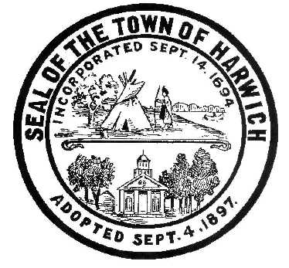 HARWICH
732 Main Street
Harwich, MA 02645

CONSERVATION COMMISSION
PHONE (508)-430-7538 FAX (508)430-7531
HARWICH CONSERVATION COMMISSION - AGENDA
SEPTEMBER 15, 2021 – GRIFFIN ROOM – TOWN HALL
Regular Session – 6:30 PM

*Public may attend the meeting in person, access the meeting on Channel 18 (Broadcasting Live), or can login to the meeting using the following login information*

Please join my meeting from your computer, tablet or smartphone.
https://global.gotomeeting.com/join/799030797

You can also dial in using your phone.
United States: +1 (872) 240-3412

Access Code: 799-030-797

New to GoToMeeting? Get the app now and be ready when your first meeting starts: https://global.gotomeeting.com/install/799030797

6:30 PM HEARINGS
All hearings shall be subject to discussion, taking of testimony, review of submitted and documents which may result in a vote being taken to approve or deny a project; or to issue a continuance to a time and date certain in order to receive and review further information as needed.
The following applicants have filed a Request for Determination of Applicability

Harwich Conservation Trust, 0 Hoyt Rd & 0 Bank St, Map 23 Parcel C1 & C1-1. Invasive management throughout Cold Brook Preserve.

Alfred Weaver, 23 Wequasset Rd, Map 5 Parcel K1-42. Construct a 10x10 shed.

The following applicants have filed a Notice of Intent

Mark and Debra Ellis, 23 Mill Rd, Map 15 Parcel U4-32. Proposed access steps, elevated walkway, and vista management.

William Ebben, 0 Snow Inn Rd, Map 15 Parcel N8-B. Proposed pier, ramp, float, and dredging.

Kerry Sullivan, 123 Riverside Dr, Map 4 Parcel A1-A10. Proposed pool, outbuilding, patio, and landscaping.

Discussion and possible vote regarding clearing in the 200’ Riverfront Area pre-emptively without a permit at 123 Riverside Drive.

Orders of Conditions
Michael and Mary Beth Donovan, 5 Trinity Cove, Map 1 Parcel E3-9. SE32-2472. Removal of portion of existing dwelling and patio, construction of addition and deck, and associated planting.

Sheila and Alfred Quirk, 11 Prince Charles Drive, Map 110 Parcel S26. Amendment to SE32-2402. Proposed 4’ deck extension and associated plantings.

The following applicants have filed a Request for a Certificate of Compliance:
David and Kimberly Sterling, 2267 Rt28 – Head of the Bay Rd, Map 119 Parcel N6. SE32-2227. Demo and reconstruction of a house with mitigation plantings and landscaping.
MINUTES
March 17, 2021
July 7, 2021
August 18, 2021
ANY OTHER BUSINESS WHICH MAY COME BEFORE THE COMMISSION
Authorized posting officer: Posted by: Town Clerk
Melyssa Millett
Signature Date: 9/10/21

