TOWN OF 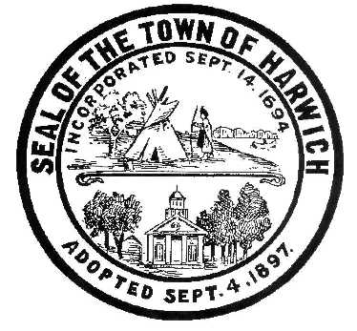 HARWICH
732 Main Street
Harwich, MA 02645

CONSERVATION COMMISSION
PHONE (508)-430-7538 FAX (508)430-7531
HARWICH CONSERVATION COMMISSION - AGENDA
SEPTEMBER 1, 2021 – GRIFFIN ROOM – TOWN HALL
Executive Session – 6:00 PM
Regular Session – 6:30 PM

*Public may attend the meeting in person, access the meeting on Channel 18 (Broadcasting Live), or can login to the meeting using the following login information*

Please join my meeting from your computer, tablet or smartphone.
https://global.gotomeeting.com/join/408416309

You can also dial in using your phone.
United States: +1 (571) 317-3122

Access Code: 408-416-309

New to GoToMeeting? Get the app now and be ready when your first meeting starts: https://global.gotomeeting.com/install/408416309

6 PM EXECUTIVE SESSION
Discussion of Court Case filed by Benjamin and Rita Stevens – 19 Wequasset Rd
6:30 PM HEARINGS
All hearings shall be subject to discussion, taking of testimony, review of submitted and documents which may result in a vote being taken to approve or deny a project; or to issue a continuance to a time and date certain in order to receive and review further information as needed.
The following applicants have requested to Amend an Order of Conditions

Sheila and Alfred Quirk, 11 Prince Charles Drive, Map 110 Parcel S26. Proposed 4’ deck extension and associated plantings.

The following applicants have filed a Notice of Intent
Daniel and Laura Dubin, 27 Walkerwoods Dr, Map 94 Parcel A5-6. Proposed seasonal pier, access path, and kayak rack.

Michael and Mary Beth Donovan, 5 Trinity Cove, Map 1 Parcel E3-9. Removal of portion of existing dwelling and patio, construction of addition and deck, and associated planting.

Orders of Conditions

Francis Zarette, 11 Harbor Way, Map 1 Parcel H3. Proposal to eliminate proposed bulkhead, rearrange and adjust scope of plantings. Amended Order SE32-2242.

Ken Tomasian, 17 Indigo Lane, Map 80 Parcel D112. Proposed one-bedroom dwelling on a vacant lot.

William and Caroline Counselman, 5 Fiddler’s Landing, Map 6 Parcel A1-8. Demo and replace a single family dwelling and make site improvements.

Ronald and Jennifer Paasch, 7 Prince Charles Drive, Map 110 Parcel S27. After-the-fact permit for shed and deck.

Michael and Sheila LeBlanc, 28 Wah Wah Taysee Road, Map 6 Parcel F1-12. Proposed elevated walkway and landing.

Discussion and Possible Vote
Discussion of current and proposed future practices regarding the Town-owned bogs at 374 Main Street, currently leased by the Main Street Cranberry Company.
Discussion of violations at 52 and 47 North Road with Tom Smith
Adoption of new regulation pertaining to the Attorney General’s acceptance of the change to the Bylaw to allow for in-lieu fees as mitigation.
Discussion about presentation of proposed Water Dependent Structures Bylaw and Wetlands Protection Bylaw in anticipation of the Board of Selectmen meeting on the topic on September 7, 2021, and Special Town Meeting October 18, 2021.
Start of management of old Bog area at the Bells Neck Conservation Area
MINUTES
February 17, 2021
March 17, 2021
July 7, 2021
August 18, 2021
ANY OTHER BUSINESS WHICH MAY COME BEFORE THE COMMISSION
Authorized posting officer: Posted by: Town Clerk
Melyssa Millett
Signature Date: 8/27/21

