TOWN OF 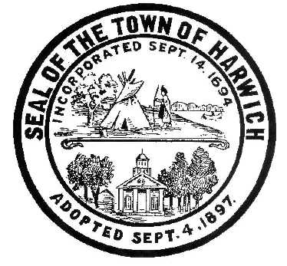 HARWICH
732 Main Street
Harwich, MA 02645
CONSERVATION COMMISSION
PHONE (508)-430-7538 FAX (508)430-7531
HARWICH CONSERVATION COMMISSION - AGENDA
TOWN HALL – GRIFFIN ROOM – HYBRID MEETING
WEDNESDAY SEPTEMBER 7, 2022 – 6:30 PM
*Public may attend the meeting in person, access the meeting on Channel 18 (Broadcasting Live), or can login to the meeting remotely using the following login information*
Please join my meeting from your computer, tablet or smartphone.
https://meet.goto.com/738019093
You can also dial in using your phone.
United States: +1 (571) 317-3122
Access Code: 738-019-093
New to GoToMeeting? Download the App here: https://meet.goto.com/install
6:30 PM HEARINGS
All hearings shall be subject to discussion, taking of testimony, review of submitted and documents which may result in a vote being taken to approve or deny a project; or to issue a continuance to a time and date certain in order to receive and review further information as needed.
The following applicants have requested a Change in Plan
Joseph and Kathleen Reis, 4 Eastern Avenue, Map 6 Parcel G3-8. SE32-2447. Request to reconfigure the approved patio.

The following applicants have filed a Request for Determination of Applicability
Traci and John Doherty, 98 Chase Street, Map 11 Parcel S7-1. Addition.

The following applicants have filed a Notice of Intent
Richard Tupper, 1 Shore Drive, Map 78 Parcel B10. Raze and Replace Single Family Swelling and Septic.

Daniel Mento, 3 Mark Lane, Map 30 Parcel G5-3. New Dwelling.

Daniel Mento, 116 Sisson Road, Map 30 Parcel G5-4. New Dwelling.

Orders of Conditions

Ken Tomasian, 17 Indigo Lane, Map 80 Parcel D112. Amendment to SE32-2471. Addition of a screened porch to an approved single family dwelling.
Katherine Seufert Green, 2261 Head of the Bay Rd, Map 119 Parcel N5. Amendment to SE32-2425. Addition of a stone patio to an approved renovation plan.

The following applicants have requested a Certificate of Compliance
Tetra Tech, 15 Glendoon Rd, Map 12 Parcel X3-41. SE32-2420. Gas remediation.

Karen Agnew and John Huth, 3 Hulse Point Road, Map 6 Parcel A2-4. SE32-2261. Additions and vegetation management.

Discussion and Possible Vote
2 Harvest Hollow – Unpermitted Fence
Skinequit CPC Application
Sea Way Beach at Old Mill Point
Chloe’s Path
Fertilizer Bylaw

Minutes
October 2, 2019

ANY OTHER BUSINESS WHICH MAY COME BEFORE THE COMMISSION
Authorized posting officer: Posted by: Town Clerk
Melyssa Millett 9/1/2022 Signature Date

