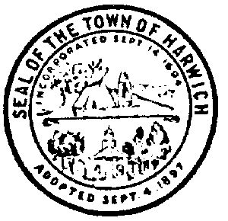

Harwich Youth Services Committee
728 Main Street • Harwich, MA 02645

MEETING AGENDA
Monday, September 13, 2021 5:00 p.m. Albro House

- Call to order
- Youth Counselor’s Report
- APG Recovery Build Speaker Series Monomoy High School
- Harwich Children’s Fund Corn Hole Tournament Oct. 2nd
- Community Kickball Event Friday October 22nd.
- New membership
- Other

Meredith Henderson Date:
Signature Authorized Posting Officer
Posted by:
Town Clerk

