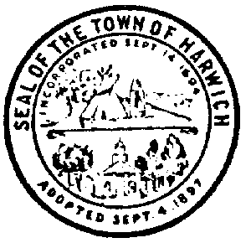

Harwich Youth Services Committee
728 Main Street • Harwich, MA 02645

MEETING AGENDA

Date: May 10, 2021
Time: 5:00 PM
Location: Online

Harwich Youth Services Committee
Mon, May 10, 2021 5:00 PM - 7:00 PM (EDT)

Please join my meeting from your computer, tablet or smartphone.
https://global.gotomeeting.com/join/176490237

You can also dial in using your phone.
United States: +1 (872) 240-3311

Access Code: 176-490-237

New to GoToMeeting? Get the app now and be ready when your first meeting starts: https://global.gotomeeting.com/install/176490237

- Call to order.
- Youth Counselor’s Report
- · RecoveryBuild APG presentation 4/27 to BOS
- · Save A Life Tour New Date
- · Review of Family Fun Fair April 10th
- · Girl Power Expansion (WeCan, Cape & Islands United Way)
- Other

Meredith Henderson Date: 5/5/2021
Signature Authorized Posting Officer
Posted by:
Town Clerk

