**TOWN *OF*** *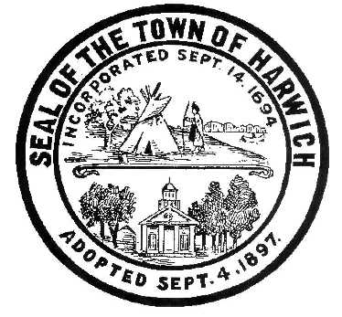* ***HARWICH***

***HARWICH ACCESSIBILITY RIGHTS COMMITTEE***

***Harwich Town Hall Small Conference Room***

***Thursday February 22, 2018 6:30 PM***

***MINUTES***

Meeting Called to Order: 6:30 pm MEETING CANCILLED DUE TO LACK Of A Quorum

Attendance, Introductions:

MINUTES: Review & Approval

OPEN FORUM:

OLD BUSINESS:



NEW BUSINESS:



MONTHLY REPORTS:

CORRESPONDANCE:

NEXT MEETING: Thursday, 2018

ADJOURNMENT:

Posting Date: W. Matthew Hart, Chairman Matt's Signature2_Pic1

*The committee may hold an open session for topics not reasonably anticipated by the Chair 48 hours in advance of the meeting following “New Business.” If you are deaf or hard of hearing or a person with a disability who requires an accommodation, contact the Selectmen’s Office at 508-430-7513***.**