**TOWN *OF*** *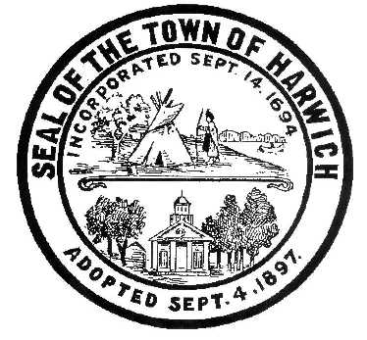* ***HARWICH***

***HARWICH ACCESSIBILITY RIGHTS COMMITTEE***

***Harwich Town Hall Small Conference Room***

***Thursday June 28, 2018 6:30 PM***

***MINUTES***

***Meeting was cancelled due to a lack of a Quorum***

Meeting Called to Order: 6:30 pm

Attendance, Introductions:

MINUTES: Review & Approval

OPEN FORUM:

OLD BUSINESS:



NEW BUSINESS:



MONTHLY REPORTS:

CORRESPONDANCE:

NEXT MEETING: Thursday, July 26, 2018

ADJOURNMENT:

Posting Date: W. Matthew Hart, Chairman Matt's Signature2_Pic1

*The committee may hold an open session for topics not reasonably anticipated by the Chair 48 hours in advance of the meeting following “New Business.” If you are deaf or hard of hearing or a person with a disability who requires an accommodation, contact the Selectmen’s Office at 508-430-7513***.**