**TOWN *OF*** *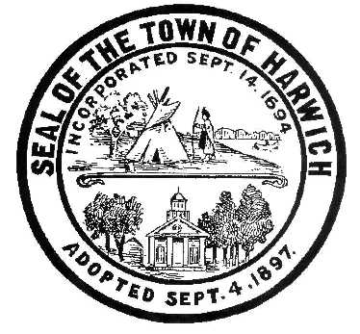* ***HARWICH***

***HARWICH ACCESSIBILITY RIGHTS COMMITTEE***

***Harwich Town Hall Small Conference Room***

***Thursday, November 30, 2017 6:30 PM***

***MINUTES***

Meeting Called to Order: 6:30 pm

Attendance, Introductions: Karin Larson, Gary Miller, Matt Hart and Carla Burke

MINUTES: Review & Approval

September 28, 2017 Motion by Karin L., Seconded by Gary M. Approved 3-0

(October 19, 2017 Meeting Cancelled due to lack of Quorum)

OPEN FORUM:

OLD BUSINESS:

1. Discussion about the future priorities

NEW BUSINESS:

1. Discussions about physical, sight and hearing access for the Disabled in Harwich being a priority.
2. Discussion about status of the two grants, Award Decisions in January 2018
3. Access at Saquatucket Marina
4. Self-Analysis Consultant
5. Request by Pleasant Bay Community Boating; Charles Sumner: Endorsement for replacement dock that meets ADA requirements.

Motion by Gary M. 2nd by Karin L vote 3 – 0 in favor

1. Discussion about new membership

MONTHLY REPORTS:

Board of Selectmen

CORRESPONDANCE:

NEXT MEETING: Thursday December, 28, 2017

ADJOURNMENT:

Motion to adjourn, Karin L. 2nd by Gary M. at 8:25 pm Approved

Posting Date: W. Matthew Hart, Chairman Matt's Signature2_Pic1

*The committee may hold an open session for topics not reasonably anticipated by the Chair 48 hours in advance of the meeting following “New Business.” If you are deaf or hard of hearing or a person with a disability who requires an accommodation, contact the Selectmen’s Office at 508-430-7513***.**