**TOWN *OF*** *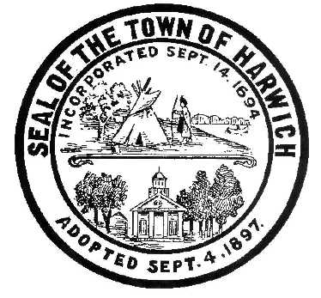* ***HARWICH***

***HARWICH ACCESSIBILITY RIGHTS COMMITTEE***

***Harwich Town Hall Small Conference Room***

***Thursday, October 26, 2017 6:30 PM***

***MINUTES***

Due to a series of conflicts that would mean there would not be a Quorum the scheduled October was cancelled, and the cancellation was posted on Monday October 23, 2017. The next meeting of the HARC Committee will be on Thursday November 30, 2017.

Attendance and Introductions:

MINUTES: Review & Approval

OPEN FORUM:

OLD BUSINESS:

NEW BUSINESS:

MONTHLY REPORTS:

Board of Selectmen

CORRESPONDANCE:

NEXT MEETING:

ADJOURNMENT:

Posting Date: W. Matthew Hart, Chairman Matt's Signature2_Pic1

*The committee may hold an open session for topics not reasonably anticipated by the Chair 48 hours in advance of the meeting following “New Business.” If you are deaf or hard of hearing or a person with a disability who requires an accommodation, contact the Selectmen’s Office at 508-430-7513***.**