**TOWN *OF*** *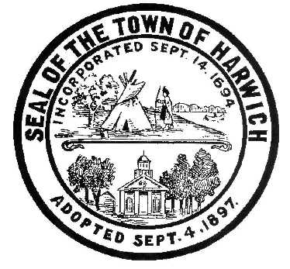* ***HARWICH***

***HARWICH ACCESSIBILITY RIGHTS COMMISSION***

***Harwich Town Hall Small Conference Room***

***Thursday September 28 , 2017 6:30 PM***

***MINUTES***

Meeting called to order at 6:35 pm:

Attendance and Introductions:

Members Present: Taylor Mills, Gary Miller, Karin Larson and Matt Hart

Others present: Carla Burk and Larry Ballantine, BOS Representative

MINUTES: Review & Approval: There were no previous Meetings available

OPEN FORUM: Informal Introduction of newly nominated HARC committee.

NEW BUSINESS:

1. Election of Officers:

Motion by Tab Mills to nominate Matt Hart for Chairman

Seconded by Karin Larson

No other nominations offered

Vote 3 for; no votes against, 1 abstention (Matt Hart) Mr. Hart elected

Motion by Matt Hart for Gary Miller for Vice Chairman

Seconded by Tab Mills

No other nominations offered

Vote 4 for; no votes against; Mr. Miller elected

1. Review of HARC (DRAFT) MISSION STATEMENT
2. Review of HARC (DRAFT) ADA Self Evaluation Process
3. Review of HARC (DRAFT) ADA Self Evaluation for Harwich Municipal Offices
4. Discussion about being a Commission or Committee
5. Discussion and vote to submit documentation for ADA Planning Grant

Motion by Tab Mills, 2nd by Karin Larson 4 to 0 In Favor of motion

OLD BUSINESS:

1. No old business to discuss

MONTHLY REPORTS:

Board of Selectmen; Nothing this month

CORRESPONDANCE:

Nothing this month

NEXT MEETING:

Thursday October 26, 2017

ADJOURNMENT:

Motion to Adjourn by Tab Mills, 2nd by Gary Miller approved at 7:45 pm

Posting Date: October 12, 2017 W. Matthew Hart, Chairman Matt's Signature2_Pic1

*The committee may hold an open session for topics not reasonably anticipated by the Chair 48 hours in advance of the meeting following “New Business.” If you are deaf or hard of hearing or a person with a disability who requires an accommodation, contact the Selectmen’s Office at 508-430-7513***.**