TOWN OF 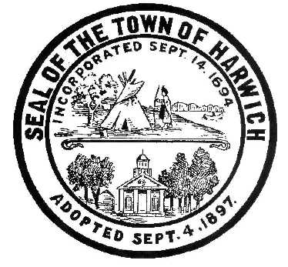 HARWICH
WATERWAYS COMMITTEE
Harwich Fire Station Conference Room
Wednesday, January 17, 2018 6:30 PM
AGENDA

Attendance and Introductions:

MINUTES: Review & Approval

OPEN FORUM:

FINANCIAL REPORT YTD & Monthly

OLD BUSINESS:
- Update and progress with Landside Construction & Bid process
- Update and progress with Waterside Marina Construction

NEW BUSINESS:
- Harwich Employees and Committee Members State Ethics Update; Signature Page

MONTHLY REPORTS:
Board of Selectmen
Harbormaster
Natural Resource Officer

CORRESPONDANCE:

NEXT MEETING:
Wednesday February 21, 2018

ADJOURNMENT:

Posting Date: January 12, 2018
The committee may hold an open session for topics not reasonably anticipated by the Chair 48 hours in advance of the meeting following “New Business.” If you are deaf or hard of hearing or a person with a disability who requires an accommodation, contact the Selectmen’s Office at 508-430-7513.

