TOWN OF 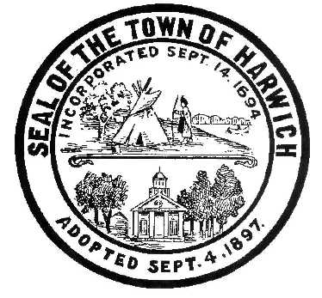 HARWICH
WATERWAYS COMMITTEE
Harwich Fire House Conference Room
Wednesday, November 15, 2017
6:30 PM
WATERWAYS COMMITTEE MINUTES 11/15/2017

Call to Order: 6:30 pm
Members Present: Matt Hart, Chairman; Tom Themistos, Mort Terry, Joe Johnson, Jay Walpole, Roger Peterson, Dan Casey, Steve Root,
Members Absent: Dan Hall
Others Present: John Rendon, Harbormaster; Heinz Proft, Natural Resources Director

MINUTES: Steve Root suggested changes in October 18th minutes; add “October” to the header date, and also remove “and” from Old Business #2. Motion made by Steve Root to Approve the Minutes with revisions of October 18, 2017, Seconded by Tom Thermistos. Approved by all.

OPEN FORUM: Nothing this month

FINANCIAL REPORT YTD & MONTHLY:

Presented by Harbormaster Rendon and Steve Root (Copy included with the Minutes).

OLD BUSINESS:
- Update and progress of Landside Development from Harbormaster Rendon. Eastward Company came in as lowest bidder and will be awarded the bid at the BoS meeting Monday, November 20, 2017. Discussion about timeline of work to be performed and hopes to be finished by Memorial Day 2018. Harbormaster Rendon also requested the Committee’s support at the BoS Meeting Monday, November 20, 2017 @ 6:30.
- Update and progress with the Waterside Marina replacement by Harbormaster Rendon. Dredging has begun with one scow and anticipates an additional scow by the end of the month. This will speed up the process and help stay on track with initial timeline and deadline of January 15, 2018. Discussion ensued about the dredging process.

NEW BUSINESS:
- Chairman Hart discussed there are multiple interested parties in bidding for a Landside Restaurant. Initial plans of a 60 seat snack shack may be increased to a 100 seat restaurant to produce revenue for the TOH; pending septic plans and terms of lease agreement which would be fully funded by the Restaurant owners. No taxpayer money would be used. Discussion ensued about timeline of septic and paving in conjunction with the new Harbormaster building. Also, to keep the look and feel of the buildings the same. Artist area will be behind the Harbormaster building.

MONTHLY REPORTS:
Board of Selectmen-Nothing this month

Harbormaster-Nothing this month

Natural Resources- Natural Resource Director Proft discussed how mitigation funds are being spent on plantable seeds and quahogs that will be relocated to areas where funds were derived from. Proft also mentioned that he will be discussing rates and a possible increase in shellfish permits at the BoS meeting December 11, 2017.

CORRESPONDANCE: Nothing to discuss

NEXT MEETING: Thursday, December 14, 2017 @ 6:30pm

ADJOURNMENT: Motion by Steve Root to adjourn at 7:55pm, seconded by Tom Themistos. All members voting in favor.

Minutes recorded by Leah McPherson

Posting Date:
The committee may hold an open session for topics not reasonably anticipated by the Chair 48 hours in advance of the meeting following “New Business.” If you are deaf or hard of hearing or a person with a disability who requires an accommodation, contact the Selectmen’s Office at 508-430-7513.

