TOWN OF HARWICH

WATERWAYS COMMITTEE
Harwich Fire House Conference Room
Wednesday, Oct. 19 , 2016
6:30 PM
MINUTES

WATERWAYS COMMITTEE AGENDA and MINUTES for Oct. 19, 2016

Due to some previous commitments by members of the committee it would mean we would not have a quorum for the Oct. 19, 2016 meeting.

I am therefore cancelling the Oct. Committee Meeting in advance of the date and requesting that we move all pending items to the November 16, 2016 Committee Meeting. I will be sending out an agenda for the November meeting during the first portion of the month.

Thank you

Matt Hart
Chairman Harwich WWC

Chairman: W. Matt Hart Date: Nov. 09, 2016
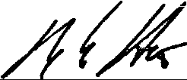
Signed:

