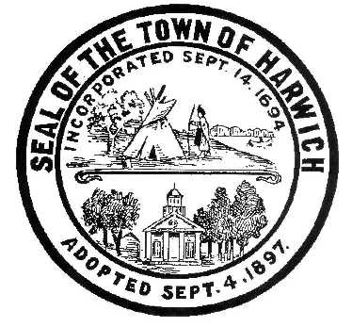Town of Harwich
Board of Health
732 Main Street Harwich, MA 02645
508-430-7509 – Fax 508-430-7531
E-mail: health@town.harwich.ma.us

January 11, 2021

Weekly COVID-19 Case Update

CASES AND STATISTICS

To date there have been a total of 350 cases of COVID-19 in the Town of Harwich. As of today, we are following 44 active cases of COVID-19 in Harwich residents (not including Wingate), the largest case load we have seen at one time to date. These active cases include household spread that started from gatherings or travel over the school break, however many cases are from unknown origin.

Harwich has been moved back into the “red” which designates us as a High Risk Community. This designation is made when a community of our size reaches a positivity rate of over 5% and has had more than 25 positive cases in a two week period. We have a positivity rate of 5.15% and 55 new cases in the last 2 weeks.

Over the weekend Barnstable County's 3-day new case tally set another new record--481 cases were recorded between 1/8 and 1/10.
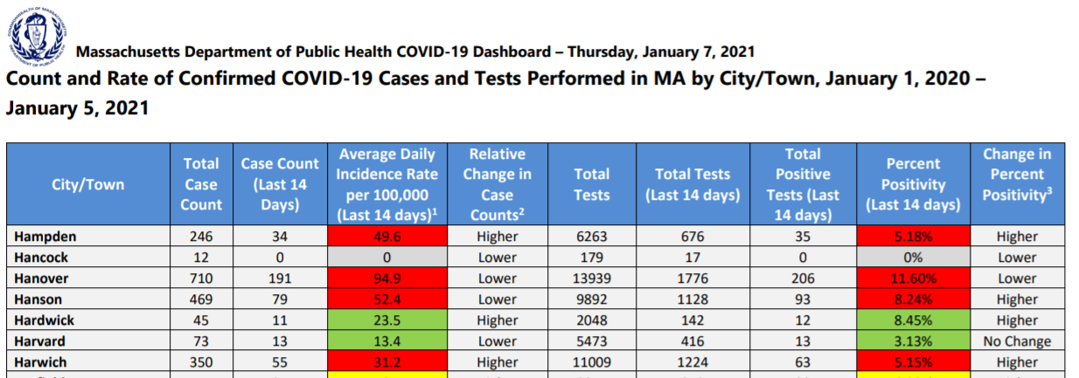

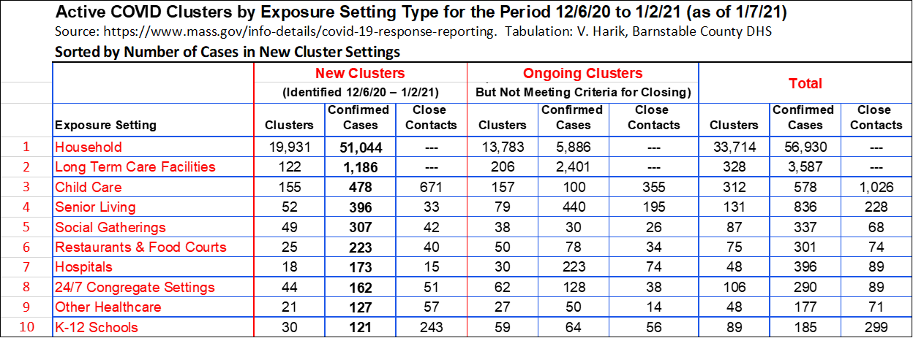

RE-OPENING PLANS

Governor Baker announced that the temporary extension of Order #59 will continue until noon on January 24, 2021. This Order limits capacity inside most businesses to 25%, including restaurants as well as reduces the gathering limitations to 10 people inside and 25 outside. This gathering limit includes private and public property. Businesses that fall into this Order must also close to the public at 9:30 pm.

VACCINE UPDATE

COVID vaccine clinics have been set up for First Responders this week. Police, Fire, Harbormasters and private EMS company employees performing COVID-facing jobs are eligible to receive their first dose of vaccine during this current phase.

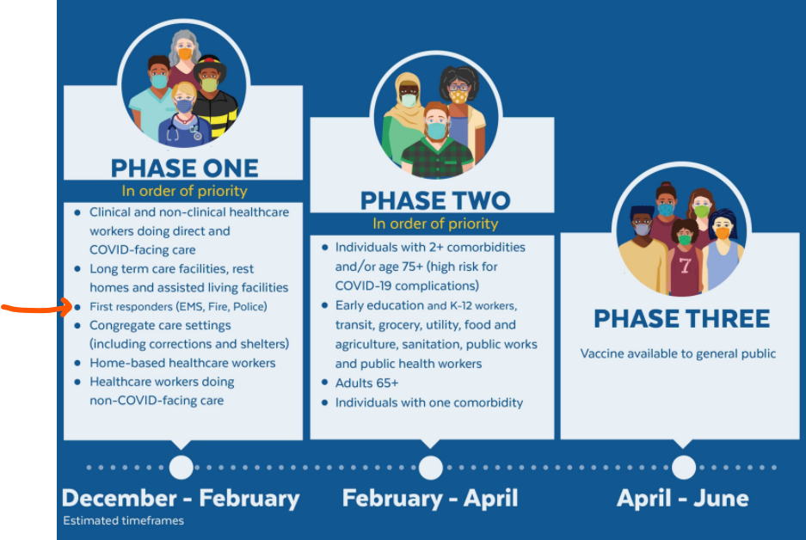

We are receiving many calls from residents wondering how they can get a vaccine. If you are in Phase one, your employer is responsible for ordering and distributing vaccine or you can attend one of the mass vaccination sites that the State has set up.

Once we get to Phase 2, we will take direction from the DPH on how to set up our clinics. We are NOT taking appointments or requests for appointments at this time. When we know more information, we will alert the public. Many pharmacies will also be providing COVID vaccine.

Harwich relies on both the VNA and the Barnstable County Department of Health and Environment for vaccine distribution. The County has agreed to be a vaccine depot for towns on the Cape. This means that the County will receive, store and distribute COVID vaccine to individual towns. When the DPH indicates that it is time to hold public clinics, Harwich will hold clinics for our residents in a similar setting as our drive-through flu clinics. We may or may not regionalize with a neighboring town to hold a clinic, this is to be determined.

More information on the Vaccine plan can be found here:
https://www.mass.gov/info-details/when-can-i-get-the-covid-19-vaccine

TESTING
Outer Cape Health Services has announced that they are extending FREE asymptomatic testing for people through February 28, 2021. This is the rapid antigen test and is not valid for Travel Order compliance. PCR testing is also available here. For testing options at Outer Cape Health, please call 508-905-2888 in advance to make a testing appointment.
Testing is available in other locations 7 days per week through Cape Cod Healthcare. Call the Community Testing Line at 508-534-7103 to make an appointment.
CLOSING MESSAGE
We continue to see community spread of COVID-19 in Harwich. Outer Cape Health services has reported that 60% of all of the positive rapid tests that they performed have been from asymptomatic individuals. It is so very important to limit close contact with other people, including children. Sleepovers, playdates, dinner parties etc. are known to spread the virus from seemingly healthy people to other people who work with the public. Teenagers spread it to parents, who bring it to work and infect others. The cycle needs to break, we need to do a better job of stopping the spread. The vaccine will help, but social distancing and wearing a mask are immediate and effective ways to do your part to stop the spread.

See you next week!
Meggan Eldredge
Health Director

