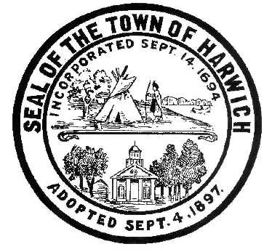Town of Harwich
Board of Health
732 Main Street Harwich, MA 02645
508-430-7509 – Fax 508-430-7531
E-mail: health@town.harwich.ma.us

October 1, 2020

Weekly COVID-19 Update

Over the last 14 days, Harwich has seen 8 new confirmed cases of COVID-19, bringing our cumulative total to 157. This increase has put us into the “yellow” category on the Department of Public Health’s map. We are following a total of 6 active cases in Harwich right now.

To date 4699 people in Harwich have been tested for COVID-19 and our positivity rate has increased to 1.65%. Hospitalizations seem to be on the rise with 7 people inpatient at the two facilities on the Cape, one in ICU.

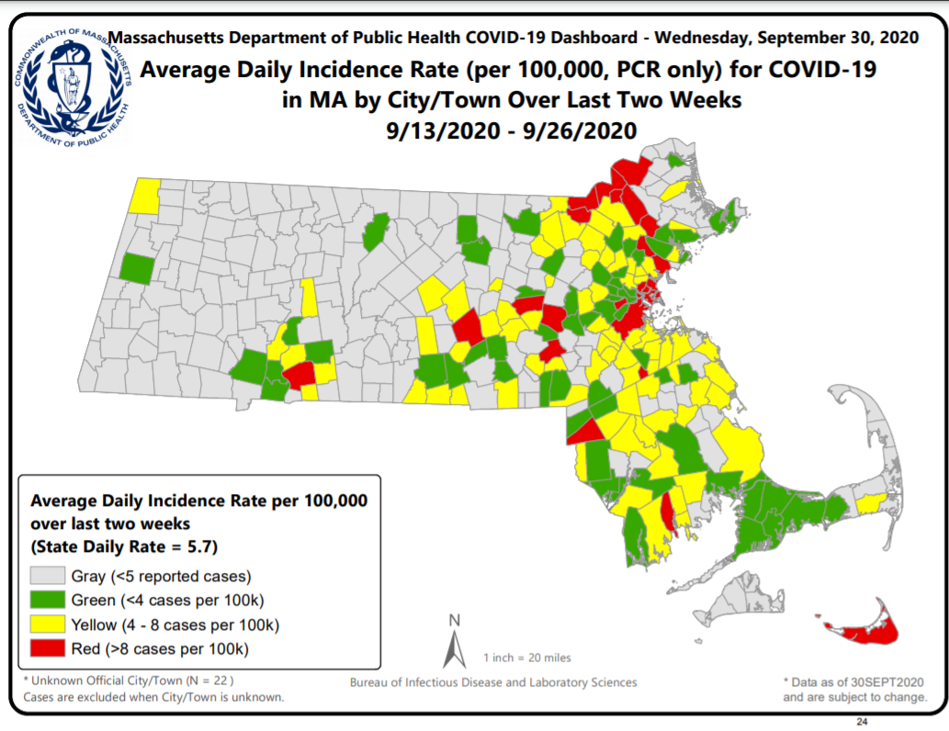
Because Harwich has not been “red” over the last three week, we are able to move into Phase 3, Step 2 of the reopening plan. Major changes to this new step are as follows:

Effective October 5, a limited number of sectors will be eligible to reopen, with restrictions, in Step II of Phase III for lower risk communities only:

- Indoor performance venues will be permitted to open with 50% capacity with a maximum of 250 people.

- Outdoor performance venue capacity will increase to 50% with a max of 250 people.

- For arcades and indoor and outdoor recreation businesses, additional Step II activities like trampolines, obstacle courses, roller rinks and laser tag will also be permitted to open and capacity will increase to 50%.

- Fitting rooms will be permitted to open in all types of retail stores.

- Gyms, museums, libraries and driving and flight schools will also be permitted to increase their capacity to 50%.

Revised Gatherings Order:

- The limit for indoor gatherings remains at a maximum of 25 people for all communities.

- Outdoor gatherings at private residences and in private backyards will remain at a maximum of 50 people for all communities.

- Outdoor gatherings at event venues and in public settings will have a limit of 50 people in Step I communities, and a limit of 100 people in lower risk, Step II communities.

For full reopening standards for these specific sectors, please visit https://www.mass.gov/info-details/reopening-massachusetts

Communities are at risk of moving back into Step 1 of Phase 3 if our case incidence is above 8 per 100,000 for three weeks in a row. Let’s stay out of the red!

Meggan Eldredge
Health Director

