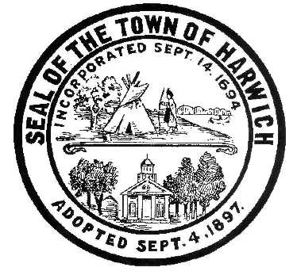Town of Harwich
Board of Health
732 Main Street Harwich, MA 02645
508-430-7509 – Fax 508-430-7531
E-mail: health@town.harwich.ma.us

August 27, 2020

Weekly COVID-19 Update

Once again, no new cases have been reported over the last 7 days, Harwich remains at a total of 141 confirmed cases and 24 deaths. One hundred seventeen people have recovered from COVID-19. There are currently no known active cases living in Harwich.

Barnstable County as a whole is also seeing a steady decrease in daily positives, with a cumulative total number of cases at 1594. To date, 165 people in the county have died from this virus.

To date 3584 people in Harwich have been tested for COVID-19 and our positivity rate has decreased significantly to 0.28%.

The Monomoy Regional School District held a COVID antigen test clinic for faculty on Wednesday, August 26th. Of the 257 people tested, only one person tested positive for antibodies. This person had previously been tested positive for COVID-19 by PCR test, so this result was expected. Through conversations with Superintendent Scott Carpenter, the schools are ready for teachers and students to return to in-person classes in Mid-September.

We remain in Phase 3, step 1 at this time. For the most up to date information on the re-opening plan for Massachusetts, including sector specific standards, please visit www.mass.gov

Seasonal influenza season is quickly approaching. There is a regional drive-through clinic scheduled for Saturday, September 26th from 8 am- noon at the Barnstable County Complex on Route 6A. This clinic is free and open to the public. This is unfortunately the same day as our Annual Town Meeting, but if residents are able to get there early, this is a great opportunity to obtain a shot early in the season. Most pharmacies are also offering free or low cost vaccinations. It is more important than ever to get a flu shot this year. I encourage everyone to find a clinic that is convenient to them and get a shot.

Thank you and stay well,

Meggan Eldredge
Health Director

