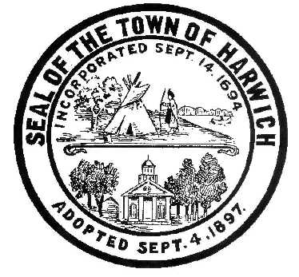Town of Harwich
Board of Health
732 Main Street Harwich, MA 02645
508-430-7509 – Fax 508-430-7531
E-mail: health@town.harwich.ma.us

DECLARATION OF PUBLIC HEALTH EMERGENCY MASK ORDER
EFFECTIVE: December 30, 2021
Pursuant to the Massachusetts General Laws, Chapter 111, Section 31, 122, 310 CMR 11.05, 105 CMR 300.200, and all other authorizing statutes and regulations, we the members of the Harwich Board of Health hereby order the following:
Masks or cloth face coverings shall be worn: While indoors in any Town owned Buildings, including but not limited to: Town Hall, Public Safety, Community Center, Cultural Center, Harbor, DPW, Libraries, etc. This shall be applicable when social distancing of 6’ cannot be maintained. This order applies to all employees, visitors, volunteers, and any member of the public who enters the buildings.
The face covering requirements of this order shall be in place until it is rescinded by the Harwich Board of Health. Full vaccination against COVID-19 remains important to reduce hospitalization and morbidity from the virus. We encourage all eligible persons who are not fully vaccinated to get immunized.
Notwithstanding any provision in this Order, pursuant to guidance issued by the CDC, face coverings should not be placed on young children under two years of age, anyone who has trouble breathing, anyone who is unconscious, incapacitated or otherwise unable to remove the mask without assistance, or anyone who due to disability or medical condition who is unable to wear a mask.
This Order shall be effective December 30, 2021 and remain in effect until notice is given, pursuant to the Harwich Board of Health’s judgement that the Public Health Emergency no longer exists.

ORDERED on this Day December 28, 2021
HARWICH BOARD OF HEALTH:

Pamela Howell, Chairman
Sharon Pfleger, Vice Chairman
Ronald Dowgiallo, Member
Matt Antoine, Member

Kevin Dupont, Member

