November 17, 2023

Town Hall of Harwich
Duncan Berry, Chair of Planning Board
c/o Shelagh Delaney
732 Main Street
Harwich, MA 02645

Subject: PB2023-34 Oliver 86 Miles Street 2- FAM
Dear Mr. Berry and Members of the Planning Board,
I am a direct abutter to the property of 86 Miles Street and have been for the past 34 years. I want to voice my opposition again strongly to the granting of a special permit for the proposed “Two-Family Dwelling”.

The original Two-Family proposal was first discussed at the February 28, 2023 Planning Board Meeting with several additional meetings throughout the next seven months. On September 12th the Oliver party requested to withdraw the original plan and come back with a revised plan. Below are my thoughts:

- 86 Miles Street is in a R-L zone (Residential – Low Density zone). It is my understanding that Low Density residential zoning promotes quality neighborhoods of conventional suburban, single-family detached homes.
- With the introduction of this new plan there have limited changes. The total living area of this new proposed second dwelling is 2,765.81 ft2. The prior plan was 2,860.62 ft2, this seems to be a rather insignificant change based on the new overall dimensions of this new plan. In addition, no changes were made to the positioning of the house on the lot. Clearly, they will be using this new house as an independent dwelling with a separate entrance if granted.
- This second dwelling clearly has its own foundation which in my opinion would indicate it to be a second house and not a Two- Family. The loophole they are clearly using is to put on series of roofs between the two houses; however, at the end of the day it is a second free standing house.
- This is a family compound which does not fit in the character of our lovely Harwich Port neighborhood. Nor, in my opinion it does not belong in a low-density area.

I feel it is also imperative that we address the so-called driveway off Grassy Pond that enters into the back of the 86 Miles Street property.

- It appears back in February 2022, there was a temporary curb cut granted. Then for the February 28th, 2023 Planning Board meeting, plans were submitted (driveway part copy below) which clearly shows it was termed “existing driveway” in those plans. How does that happen when the Planning Board had not yet received the Special permit driveway application until March 7, 2023.
- The temporary curb cut has significantly impacted the property at 38 Grassy Pond. Since the change, when it rains the top of the driveway at 38 Grassy Pond becomes flooded and the water floods the garage. This has never been a problem prior to this curb cut. This has required us to have sandbags in front of our garage and a water alarm to alert us to the excess water. This was never a problem prior to this new access. It doesn’t seem fair.
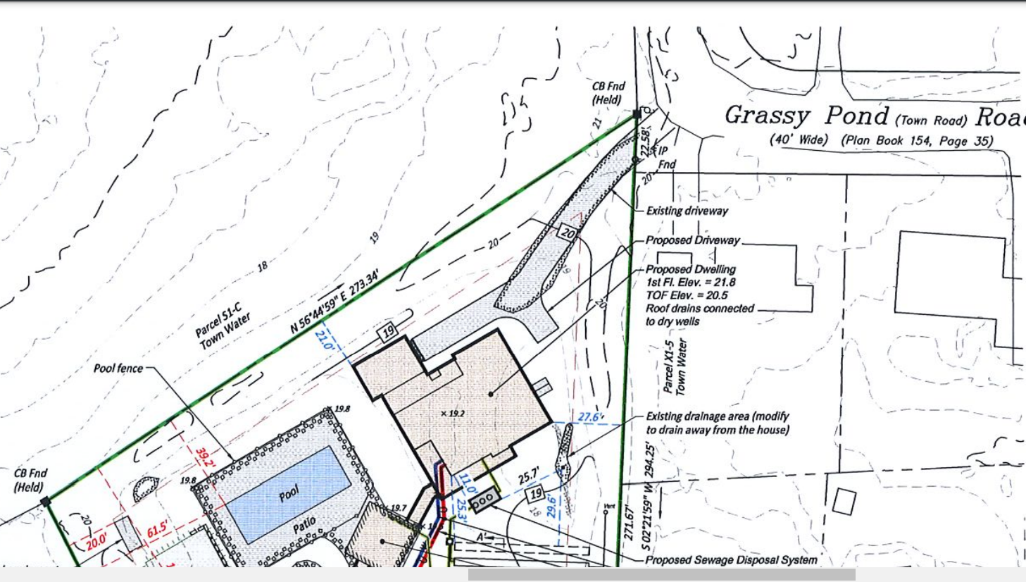

- The Special Permit for the Alternate Access driveway permit was submitted on March 7, 2023.
  - On June 5, 2023, the town’s lawyer, KP Law, submitted correspondence which references Section 325-18.K which states a lot with required legal frontage must take access along the required legal frontage. It further states that no alternative access may be granted from other streets, roads, or ways, nor should access be taken from an easement across an adjacent property without the issuance of a special permit from the Planning Board. In issuing a special permit the planning board should make the following findings;
1. The alternate access proposed is superior to the access along the frontage.
In her legal opinion (Amy E. Kwesell, Esq.), 325-18K does not provide for additional access as sub-section (1) requires the Board to find that the proposed alternate access is superior to access across the frontage. That would only apply if the access across the frontage was being relocated to the alternate street.
By granting access to this alternate driveway this will dramatically increase the traffic flow on an otherwise quiet and quaint Grassy Pond roadway. The safety of our neighbors and the community are of utmost importance and should be a priority!
I respectfully ask for you to deny this Two-Family Dwelling special permit and deny the Alternate Access/additional driveway.

Sincerely,
Allan F. Whitty
Allan F. Whitty
38 Grassy Pond Road
Harwich Port, MA 02646

