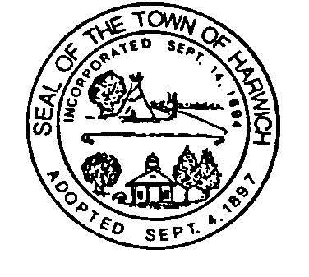TOWN OF HARWICH PLANNING DEPARTMENT

MEMO Date: August 23, 2023
To: Town Clerk
From: Shelagh Delaney, Planning Assistant
RE: PB2023-26 Peterson - Oliver Snow ANR
Approval Not Required (ANR)

You are hereby notified that the Planning Board endorsed an Approval Not Required (ANR) for 2 plans; one entitled “Division Plan (to be filed in Land Court) – Oliver Snow Road” prepared by TS Land Surveying, Inc. dated 2/13/23, revised 7/10/23, and another other plan entitled “Division Plan (to be filed with Barnstable Registry of Deeds) - Oliver Snow Road” prepared by TS Land Surveying, Inc., dated 7/10/23 (vote 6-0-0). One plan is for the Barnstable County Registry of Deeds and the other is for Land Court.
Specifically, the Board found that the Plans do not depict a subdivision and thus do not require approval under subdivision control law. (MGL 41 §§ 81L and 81P and Subdivision Rules and Regulations of the Code of the Town of Harwich).

The subject land is in the RR zoning district and is currently identified as map 24, parcel E2, #s 21 and 29 Oliver Snow Road.

Cc: Susan Peterson
Tom Stello, TS Land Surveying, Inc

