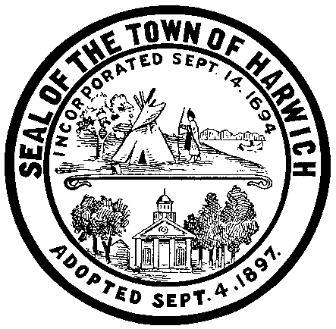
_____________
Case #
TOWN OF HARWICH

732 Main Street, Harwich, Massachusetts 02645

ZONING BOARD OF APPEALS

Notice of Comprehensive Permit Application and Petition for Public Hearing, (“APPLICATION”)

Please refer to the Rules and Regulations ot the Town of Harwich Board of Appeals for documentation requirements.
This original completed and signed notice ("Application"), along with a certified abutters list and twelve (32) copies of all plans, sketches, statements, site plans or other supporting documents per the attached checklist must be presented to the Building Department prior to being filed with the Town Clerk. The required documentation, ALL of which must be submitted on the date of filing, is listed on this Application. THE RULES AND REGULATIONS (“RULES”) OF THE TOWN OF HARWICH BOARD OF APPEALS APPLY TO ALL APPEALS AND APPLICATIONS AND SHOULD BE CONSULTED BEFORE FILING AN APPEAL OR APPLICATION TO ENSURE COMPLIANCE WITH THEM.
To the Zoning Board of Appeals, Harwich, MA:

(We, I) hereby petition your Board for a public hearing on the request for action checked below:

( ) Application for a Comprehensive Permit that is subject to Board of Appeals approval.

I/we am/are the owner[s]/agent of the property involved in this petition, which is located in Harwich, MA at the following address:
. Said property is further described on

Assessor’s Map # _ and Parcel # located in the Zoning District as shown on the attached plan.

Describe Petition/Appeal:_____________________________________________________________________________

Relief requested - Cite specific Bylaw Section(s): _________________________________________________________________________________________________

Signature of Owner (or Agent) Date
(Written authorization by the owner must accompany an Application signed by agent.)

Owner Name Phone No.

Mailing Address:

Agent Name: Phone No.

Mailing Address:

Has a petition previously been submitted for this property (Y/N)

If yes, the date of original hearing Petition No. Decision

Please be advised that an incomplete Application may result in a delay in processing your Application and may result in a denial by the Board without consideration of the merits of the Application. IT IS YOUR RESPONSIBILITY TO REVIEW THE RULES THAT APPLY TO YOUR APPLICATION AND TO MAKE SURE BEFORE FILING THAT YOUR APPLICATION COMPLIES WITH THOSE RULES. The burden of proof is on the petitioner, not on the Town. If you do not understand the criteria, legal counsel should be sought. Either the petitioner or his/her agent is required to appear at the hearing to present the Application.

All applicants for hearing before the Board of Appeals must complete the Application and submit along with it the supporting documentation listed herein to the Building Department for review and subsequent filing with the Town Clerk. The Building Department accepts Applications during posted hours. You are strongly encouraged to submit your Application to the Building Department well in advance of the filing deadline to allow adequate time for staff review for completeness. All information, including the applicable fee made payable to the Town of Harwich, must be submitted with the Application.

The application for a Comprehensive Permit shall consist of thirty two (32) sets of the following:

- Preliminary site development plans showing the locations and outlines of proposed buildings; the proposed locations, general dimensions and materials for streets, drives, parking areas, walks and paved areas; and proposed landscaping improvements and open areas within the site, signed by a registered architect.
- A report on existing site conditions and a summary of conditions in the surrounding areas, showing the location and nature of existing buildings, existing street elevations, traffic patterns and character of open areas, if any, in the neighborhood.
- Preliminary, scaled, architectural drawings. For each building the drawings shall be signed by a registered architect and shall include typical floor plans, typical elevations and sections and shall identify construction type and exterior finishes.
- A tabulation of proposed buildings by type, size (number of bedrooms, floor area) and ground coverage, and a summary showing the percentage of the tract to be occupied by buildings, by parking and other paved vehicular areas, and by open areas.
- Where a subdivision of land is involved, a preliminary subdivision plan.
- A preliminary utilities plan showing the proposed location and types of sewage, drainage and water facilities, including hydrants.
- Documents showing that the applicant fulfills the jurisdictional requirements, that is,
- the applicant shall be a public agency, a non-profit organization or a limited dividend organization;
- the project shall be fundable by a subsidizing agency under a low- and moderate-income housing subsidy program; and
- the applicant shall control the site.
- A list of requested waivers or exceptions to local requirements and regulations, including local codes, ordinances, bylaws or regulations.
- Complete list of all abutters and abutters of abutters, in accordance with the M.G.L., within 300 feet.
- "Site approval letter" from State, Federal or other qualified funding agency indicating acceptability of site.
- the Project Eligibility letter, showing that the applicant fulfills all requirements of the M.G.L. and applicable regulations.
- The original Application (additional stamped copies can be provided at a nominal fee):
- Signed by the owner or agent
- If signed by an agent, a letter of authorization signed by the owner must also be included.
- Check made payable to “Town of Harwich” for the applicable fee. Fee amounts are set forth on Exhibit A to the Town of Hariwch Board of Appleasl Rules and Regulations.

By signing and submitting this Application, you hereby authorize the members of the Board of Appeals, or its agent, to conduct a site visit of the exterior of your property for an inspection of the property involved in this petition, should they deem it appropriate.

The Board of Appeals is entitled to rely on the information contained in this Application. Therefore, the undersigned certifies that the information provided in this Application, and all submitted plans and other documentation, is true and accurate to the best of my knowledge and belief.

Agent’s Signature: Date:

Owner’s Signature: Date:

