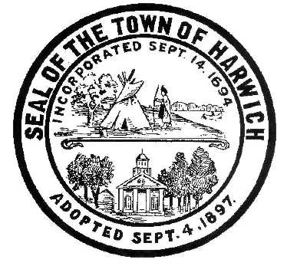Town of Harwich
Board of Health
732 Main Street Harwich, MA 02645
508-430-7509 – Fax 508-430-7531
E-mail: health@town.harwich.ma.us

January 29, 2021

Weekly COVID-19 Case Update

CASES AND STATISTICS

To date there have been a total of 481 cases of COVID-19 in the Town of Harwich. As of today, we are following 35 active cases of COVID-19 in Harwich residents (not including Wingate). We continue to have an elevated active caseload.

Harwich remains in the “red” which designates us as a High Risk Community. This designation is made when a community of our size reaches a positivity rate of over 5% and has had more than 25 positive cases in a two week period. We have a positivity rate of 6.22% which is determined by the number of tests administered. There were 1271 tests administered and 79 tests were positive in the last 2 weeks. This is lower than last week.
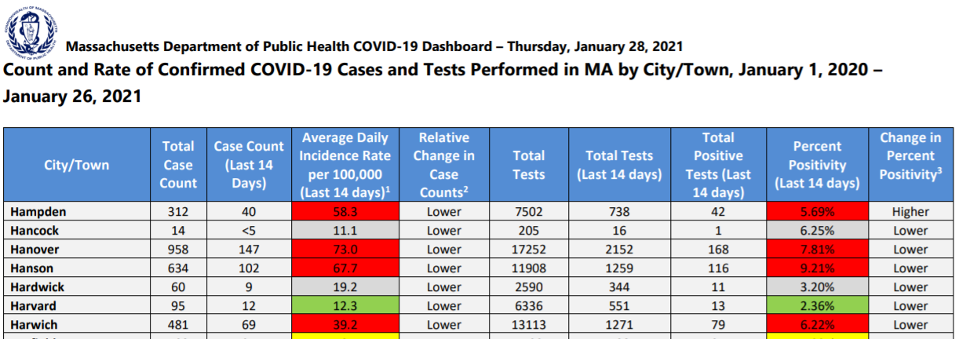

VACCINE UPDATE

As of Monday, February 1st, all groups in Phase 1 and the first group in Phase 2 (people age 75 and over) are eligible to receive the vaccine. Cape Cod can expect a State-run mass vaccination site to be operational within the next several weeks. We can also expect regional County-run clinics in the mid/lower and upper Cape areas. One County-run clinic site will be at the Cape Cod Melody Tent in Hyannis.

Individual town-run clinic will not be possible until later in Phase 2 due to the small allotment of vaccine given out at one time. The County expects to receive 975 doses of the Pfizer vaccine each week and will be distributing that through regional clinics weekly. Priority for appointment will be given to those remaining in Phase 1, and then to anyone age 75 + .

Getting an appointment for the regional clinics will be through the State website on the vaccine finder map: www.mass.gov/COVIDVaccineMap. Appointments will be hard to find early on in this phase because of the high demand and short supply. Residents may find appointments at private pharmacies faster than a regional clinic. CVS, Stop and Shop and Walgreens are filling appointment through their websites.

Vaccine distribution statistics from the Department of Public Health:
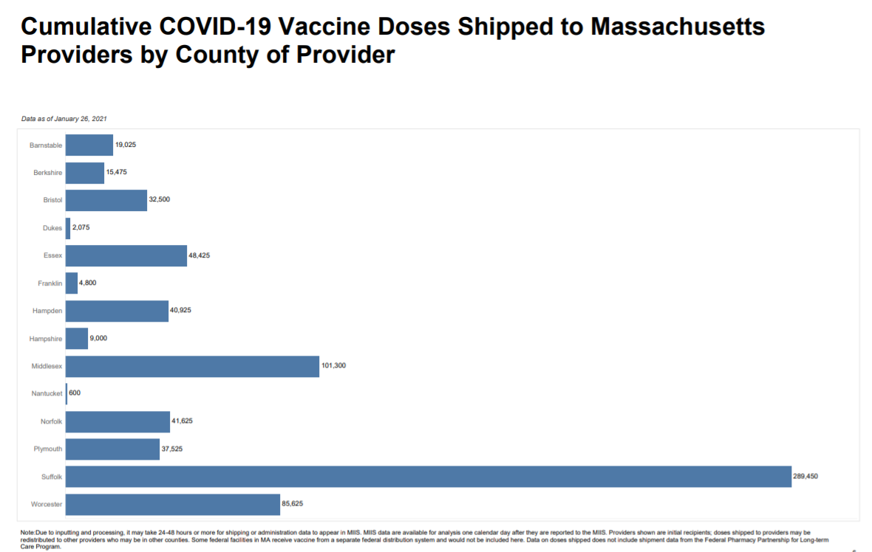

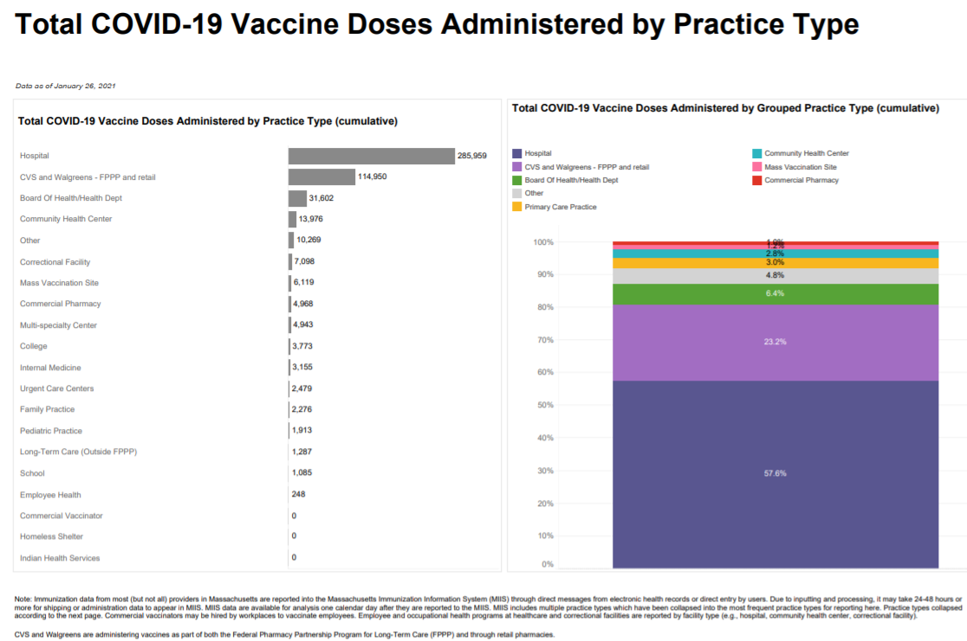

TESTING
FREE asymptomatic testing for COVID-19 is still available at Outer Cape Health Service through February 28, 2021. This is the rapid antigen test and is not valid for Travel Order compliance. PCR testing is also available here. For testing options at Outer Cape Health, please call 508-905-2888 in advance to make a testing appointment.
Testing is available in other locations 7 days per week through Cape Cod Healthcare. Call the Community Testing Line at 508-534-7103 to make an appointment.

Stay warm and stay well!
Meggan Eldredge
Health Director

