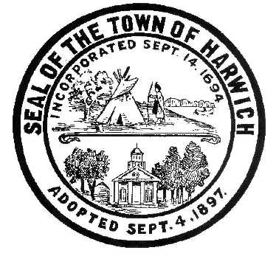Town of Harwich
Board of Health
732 Main Street Harwich, MA 02645
508-430-7509 – Fax 508-430-7531
E-mail: health@town.harwich.ma.us

February 19, 2021

Weekly COVID-19 Case Update

CASES AND STATISTICS

To date there have been a total of 563 cases of COVID-19 in the Town of Harwich. As of today, we are following 27 active cases of COVID-19 in Harwich residents. Our positivity rate has decreased again this week, 4.842% which is determined by the number of tests administered. There were 1155 tests administered and 51 tests were positive in the last 2 weeks. Our numbers are once again heading in the right direction.

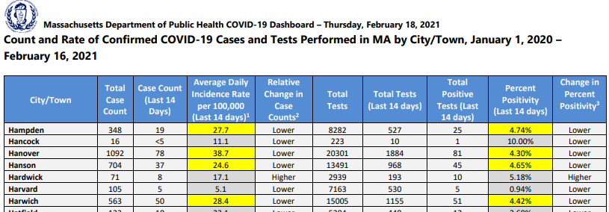

VACCINE UPDATE

The Department of Public Health announced that the next priority group in Phase 2 is eligible for vaccine starting on February 18, 2021. This priority group includes individuals age 65 and over, residents and staff of low and affordable public and private senior housing, and individuals with 2+ certain medical conditions.

This announcement came along with a letter to all Local Boards of Health from Secretary Sudders. This letter states that as of March 1st, the state will no longer provide first doses of vaccine for individual municipal clinics. Vaccine will be distributed only to regional collaborations that can meet specific needs. Barnstable County is a regional collaboration and we are working with the County to ensure equitable distribution throughout the Cape.

The state will continue to supply private retail pharmacies and medical providers with vaccine. Stop and Shop, Walgreens, CVS are eligible to receive vaccine.

Outer Cape Health Services is offering vaccine to eligible people. You do not have to be a patient of OCHS in order to get an appointment for a shot. Please contact OCHS for more information. Additionally, Carewell Urgent Care Center is also booking appointments for vaccine.

Vaccine distribution statistics from the Department of Public Health:
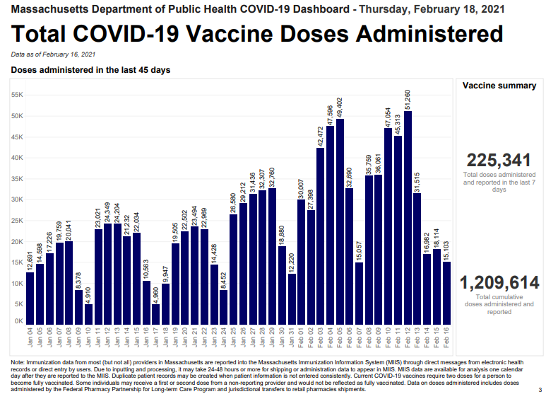

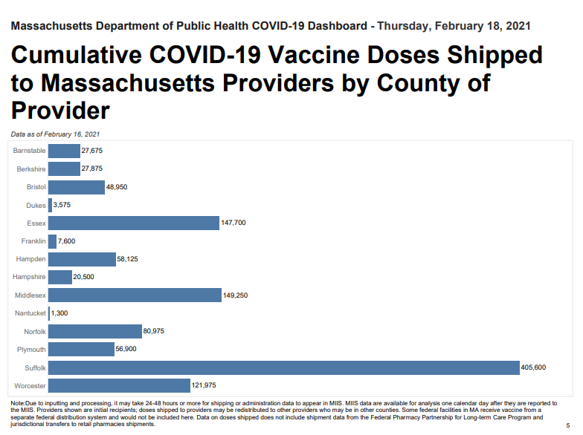

The Council on Aging is working with residents to assist them navigate through the vaccine registration process. Keep your eyes and ears open for an announcement of a Harwich resident “help line” that will be staffed on certain days and times to help those who are unable to navigate the registration system alone.

Clinics are frequently added to the www.maimmunization.org site. The COA in collaboration with Channel 18 have developed a “how-to” step by step document outlining the registration process that is available to residents.

Outer Cape Health has offered to vaccinate the homebound and most vulnerable residents in Harwich in the coming weeks. This incredible offer is greatly appreciated and we look forward to working with them on this task.

TESTING
FREE asymptomatic testing for COVID-19 is still available at Outer Cape Health Service through February 28, 2021. This is the rapid antigen test and is not valid for Travel Order compliance. PCR testing is also available here. For testing options at Outer Cape Health, please call 508-905-2888 in advance to make a testing appointment.
Testing is available in other locations 7 days per week through Cape Cod Healthcare. Call the Community Testing Line at 508-534-7103 to make an appointment.

I am optimistic about the decreasing number of cases throughout the Commonwealth as well as here in Harwich. As a reminder, if you have traveled during this school vacation week, make sure to quarantine or get tested before going back to school or work. Symptoms can be mild or non-existent, however you could be unknowingly passing the virus to someone who may not fare as well.

Meggan Eldredge
Health Director

