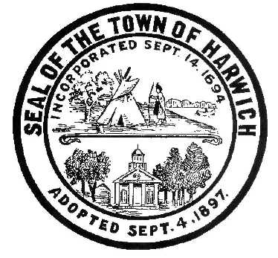**Town of Harwich**

**Board of Health**

732 Main Street Harwich, MA 02645

508-430-7509 – Fax 508-430-7531

E-mail: health@town.harwich.ma.us

March 22, 2021

Weekly COVID-19 Case Update

CASES AND STATISTICS

To date there have been a total of 606 cases of COVID-19 in the Town of Harwich. As of today, we are following 18 active cases of COVID-19 in Harwich residents. Our positivity rate has increased to 3.06% which is determined by the number of tests administered. Over the past two weeks there were 850 tests administered, and 26 tests were positive. We have been designated as “Yellow”, which indicates we have 10 or more averages cases per 100,000 people, or a greater than 5% positivity rate.

VACCINE UPDATE

Newly Eligible for Vaccine as of March 22, 2021:

* People who are 60 years or older
* Certain Workers
  + Restaurant or cafe workers, food workers, meatpacking, beverage, agriculture, consumer goods, retail, or food service workers, grocery and convenience store workers, food pantry workers or volunteers, medical supply chain workers, vaccine development workers, transit/transportation workers, public works, water, wastewater, or utility workers, sanitation workers, public health workers, court system workers, funeral directors and funeral workers. <https://www.mass.gov/info-details/covid-19-vaccinations-for-certain-workers>

Eligible as of April 5, 2021:

* People who are 55 years or older
* People with 1 certain medical condition
  + Asthma, Cancer, Chronic Kidney Disease, COPD, Down Syndrome, Heart Conditions, Immunocompromised State, Obesity and Severe Obesity, Pregnancy, Sickle Cell Disease, Smoking, Type 2 Diabetes.

Eligible as of April 19, 2021:

* If your group is not specifically listed in either Phase 1 or Phase 2, you will be eligible to receive the vaccine in Phase 3, which will launch April 19, 2021.

Currently Eligible Complete List:

Phase 1 listed in order of priority:

* Clinical and non-clinical health care workers doing direct and COVID-facing care
* Long term care facilities, rest homes and assisted living facilities
* First responders
* Congregate care settings
* Home-based health care workers
* Health care workers doing non-COVID-facing care

Phase 2 listed in order of priority:

* People who are 75 or older
* People who are 60 or older
* People with 2 or more certain medical conditions
* People who live or work in low income and affordable senior housing
* K-12 educators, K-12 school staff, and child care workers
* Certain workers

There are different ways to find a vaccine appointment if you're eligible:

* Preregister at [VaccineSignUp.mass.gov](https://vaccinesignup.mass.gov/#/) to be notified when it's your turn to schedule an appointment at oneof **7 mass vaccination locations**: Fenway Park, Gillette Stadium, Reggie Lewis Center, DoubleTree Hotel in Danvers, Eastfield Mall in Springfield, Natick Mall and former Circuit City in Dartmouth.
* Use [VaxFinder.mass.gov](https://vaxfinder.mass.gov/) to search for appointments at pharmacies, health care providers, and other community locations

Massachusetts’ preregistration system makes it easier to request and schedule an appointment at one of the 7 mass vaccination locations. Eligible people can preregister for a COVID-19 vaccine appointment at mass vaccination locations only. More locations will be added to the system in April.

Once you sign up for preregistration, you’ll receive weekly status updates. You can opt out at any time if you find an appointment elsewhere. Once an appointment is available, you’ll be contacted with the opportunity to book the appointment and have 24 hours to accept it.

Massachusetts receives a limited supply of COVID-19 vaccine doses from the federal government each week. **Due to high demand and very limited supply, it may take several weeks to schedule an appointment or to be notified that an appointment is available at mass vaccination locations.**

Individuals 75 and older without access to the internet or who are unable to preregister or schedule their appointment online can call toll free [2-1-1](tel:211) or [(877) 211-6277](tel:8772116277) for assistance.

The most up to date and valuable information on vaccination is found at: <https://www.barnstablecountyhealth.org/vaccine-information>

PHASE IV, STEP 1 OF RE-OPENING (As of March 22, 2021)

**COVID-19 Order No. 66** – Order Advancing All Communities to Phase IV, Step 1 of the Commonwealth’s Re-Opening Plan and Transitioning to a Travel Advisory Policy March 22nd, Appendix Adjusting Gathering Limits Set in COVID-19 Order No. 63.

The Baker-Polito Administration announced that Massachusetts will advance to Step 1 of Phase IV of the Commonwealth’s reopening plan on Monday, March 22. The Administration continues to take steps to reopen the Commonwealth's economy with public health metrics continuing to trend in a positive direction. This includes drops in average daily COVID cases and hospitalizations. Massachusetts also continues to be a national leader in vaccination rates. The Administration also replaced the placed the Massachusetts Travel Order originally issued in July 2020 with a Travel Advisory, effective March 22.

In addition, the Administration also announced nearly $31 million in awards to 710 additional small businesses in the tenth round of COVID-19 relief grants administered by the Massachusetts Growth Capital Corporation (MGCC).

**Phase IV, Step 1 and Gathering Changes:**

On March 1, Massachusetts loosened capacity restrictions for several industries and advanced to Step 2 of Phase III of the reopening plan. Since then, hospitalizations dropped by 20% and deaths dropped by 24%. The seven day average of new cases in long-term care facilities dropped by 53%. The positive test rate remains below 2% and has been for several weeks now. The seven day average of new cases is also down over this time by 7%.

Effective Monday, March 22, all communities in Massachusetts will move into Step 1 of Phase IV of the state’s reopening plan. This will open a range of previously closed business sectors under tight capacity restrictions that are expected to be adjusted over time if favorable trends in the public health data continue. Effective on the planned advancement to Step 1 of Phase IV, the following large capacity sports and entertainment venues will be permitted to operate at a strict 12% capacity limit after submitting a plan to the Department of Public Health (DPH):

* Indoor and outdoor stadiums
* Arenas
* Ballparks

Also effective on March 22, gathering limits for event venues and in public settings will increase to 100 people indoors and 150 people outdoors. Outdoor gatherings at private residences and in private backyards will remain at a maximum of 25 people, with indoor house gatherings remaining at 10 people.

Additionally, dance floors will be permitted at weddings and other events only, and overnight summer camps will be allowed to operate this coming summer. Exhibition and convention halls may also begin to operate, following gatherings limits and event protocols. Other Phase IV sectors must continue to remain closed.

**Travel Order:**

Effective Monday, March 22, the Massachusetts Travel Order will be replaced with a Travel Advisory.

The new travel advisory will urge all persons entering Massachusetts, including returning residents, are advised to quarantine for 10 days upon their arrival if they have been out of the state for 24 hours or more.

The advisory does not apply to anyone in the following categories:

* Anyone who is returning to Massachusetts after an absence of fewer than 24 hours.
* Travelers who have a negative COVID-19 test result that has been administered up to 72 hours prior to their arrival in Massachusetts.
* Workers who enter Massachusetts to perform critical infrastructure functions (as specified by the Federal Cybersecurity and Infrastructure Security Agency) while they are commuting to or from or while at work.
* Travelers who are fully vaccinated (i.e. who have received two doses of either the Moderna or Pfizer COVID-19 vaccines OR who have received a single dose of the Johnson & Johnson vaccine, 14 days or more ago and who do not have symptoms).

Travelers are additionally encouraged to consult and follow the CDC’s guidelines and requirements for travel.

**Highlights of Changes to the Sector-Specific Workplace Safety Standards for Phase IV, Step 1** <https://www.mass.gov/resource/reopening-sector-specific-protocols-and-best-practices>

* Theaters –removed Phase IV  reference; the beverage stations will follow restaurant rules
* Restaurants – opens self-serve beverages
* Museums – increases walking tour size to 25
* Gyms and Fitness Centers – reduced distancing requirement from 14ft to 6ft
* Retail – reopens food courts, following restaurant rules *(reiterates most important rules, per HHS)*
* Events – Clarifies that the 90 min limit does not apply for seated food service at events, removes reference to travel order

**Phase IV Enterprises that Must Remain Closed until Phase IV, Step 2**

* Amusement parks, theme parks, indoor and outdoor waterparks and ball pits
* Street festivals and parades and agricultural festivals
* Road races and other large, outdoor organized amateur or professional group athletic events
* Bars, dance clubs and nightclubs
* Beer gardens, breweries, wineries and distillates not providing seated food service

TESTING

For testing options at Outer Cape Health, please call [508-905-2888](tel:+1-508-905-2888) in advance to make a testing appointment.

Testing is available in other locations 7 days per week through Cape Cod Healthcare. Call the Community Testing Line at 508-534-7103 to make an appointment.

Katie O’Neill

Health Director

**3/21/21: Barnstable County and Regional COVID-19 Daily Update**

(N.B.  I am no longer attempting to tally new probable cases alongside new confirmed cases.  I have not received information on probable cases since 12/6/20, at which time Barnstable County had logged a total of 531.)

**Good Morning All.**

**The towns of Barnstable and Yarmouth have returned to the highest risk (red) category in terms of average 2-week new case numbers.​**

**The first case of the Brazilian variant P1 has been announced in Massachusetts in Barnstable County** (30 year-old female)**.  The contribution in Barnstable County to the new case numbers of any variants is unknown at this time.**

**In follow up to discussions between the relevant town health agents, the County, and the DPH, the DPH has stated that it will deploy additional testing resources to the mid-Cape region.**

**SUMMARY:**

**1.  New Cases:**DPH new cases reported yesterday:

**Barnstable County:        98** new cases (cases continue to increase--mid-Cape sub-region)

**Martha's Vineyard:          2**new cases  
**Nantucket:                         0** new cases  
  
 **2.  Hospitalizations and Fatalities:**3-day avg. hospitalizations (now **23**) has increased.  **5** patients were in the ICU yesterday afternoon.  There were**2 COVID fatalities** reported Friday-Sunday.  CCH and Falmouth Hospital have re-opened to limited visitation.

The first week of March marked the **one-year anniversary** of the recognition of the first COVID case in Massachusetts.​  In year 1 of this pandemic the **Barnstable County Case Fatality Rate (CFR) is 4%**, behind only Berkshire and Franklin Counties (which are also remote, rural locales), and is markedly higher than the **state CFR (2.8%)**.

Recent data on COVID fatalities in Barnstable County suggest that residents of **Long Term Care/Skilled Nursing Facilities/Rest Homes**represent **42.5%** of all fatalities (167 of 393 fatalities, as of 2/23/21).  This is a **lower**percentage than that seen during phase 1 of the pandemic last spring (over 65%), and **this percentage continues to fall.  Indeed, between 1/5/21 and 2/23/21 only 20% (28) of 137 fatalities occurred among LTC residents.**  
  
**3.  Schools and Childcare Centers:**Due to the mildness of the flu season the DPH has **removed the requirement** that all school children receive a flu vaccination on or before 2/28/21.  **School districts remain in a hybrid learning model.**  However, **DESE Commissioner Jeffrey Riley has announced plans which will compel schools to return to 100% in-person learning, starting with elementary schools, in April.**

**4.  Testing; Test Positivity Rates**(14-day, as of 3/17/21)**:**

**Barnstable County:                     4.12%** (vs. 3.22%)  (higher vs. previous fortnight)

**Dukes & Nantucket Counties:   2.32%** (vs. 1.53%)  (higher)

        A test percent positivity rate below 5% suggests that an outbreak is on the way to **containment**.

**5.  Weekly Town Risk, and Statewide Cluster Analyses**:  See charts below (analysis of 3/11/21 data is pending).

**6.  Vaccination:**

​     -Groups eligible for vaccination now are those in Phase 1, and Phase 2/Group 1 (persons aged 75+), and Phase 2/Group 2 (65+, 2+ comorbidities, residents and staff of low-income senior housing), and (effective 3/11) Phase 2/Group 3 --K-12 and early education/childcare teachers and staff, **depending upon availability of vaccine.**

 ​    -Caregivers (regardless of age) accompanying a 75+ person to their vaccination appointment remain eligible for vaccination and can receive vaccination under these circumstances at **DPH mass vaccination sites**.  Local vaccination clinics may also allow this, but most are not doing so because of constrained vaccine supplies.

**​**​-Phase 2 of the State Vaccination Plan began on February 1.  **On March 11th K-12 teachers and staff and childcare teachers and staff became eligible for vaccination.**

     -Vaccination at local clinics during Phase 2 are by appointment only and **appointments are announced and able to be scheduled once County and local health authorities are sure of vaccine availability from the DPH**.  The public is being given notice of planned vaccination clinics for eligible persons in Phase 2.

    -Plans for 4-5 sub-regional mass vaccination sites on Cape Cod, for operation during Phase 2, are in place.  A **Cape Cod Regional Vaccine Consortium** has been established via a partnership between the Barnstable County Health Dept, Local Town Boards of Health (LBOHs), Community Health Centers (CHCs), and Cape Cod Healthcare, and has received support from the DPH.  The Consortium has established a **vaccination site at Cape Cod Community College** (which opened this week) and is also working with LBOHs and CHC to **organize in-reach to homebound persons** to vaccinate them.  **The DPH is responsible for providing sufficient vaccine in order for the Consortium to reach its full potential.**

     -**The DPH has begun reporting vaccination progress age group and by town**.  Below is a summary table for Barnstable County by age group.

**7.  COVID Mutation** and Changes in Transmissibility/Virulence/Other:  **There are four variants of concern: B117 (UK), B1351 (S. Africa), P1 (Brazil), and B1526 (New York City,**which emerged in November).  All four appear to be significantly more transmissible than the virus which dominated Wave 1 of the pandemic. Within two months of the B117 variant being identified in the UK (October) it became the dominant strain circulating there.  The CDC is now posting surveillance information on the emergence of the B117 variant in the US:  <https://www.cdc.gov/coronavirus/2019-ncov/transmission/variant-cases.html>.​   Existing vaccines may be less effective against these new strains.  The degree to which this may be so is being investigated.  Moderna and Pfizer are working on a booster shot to counter these new strains.

     -B1526 now accounts for 40% of new cases in NYC

**-B117 and B1351 have been identified in Massachusetts.**

**-The first case of the Brazilian variant P1 has been announced in Massachusetts in Barnstable County.**

**REPORT DETAIL:**

**1.  New Cases**

Daily new case numbers in Barnstable County are moving upward again, following a major decline since the holiday season surge new cases are moving upward again, due to **significant case increases in the towns of Barnstable and Yarmouth**. **290 cases**were reported over the weekend (Friday to Sunday, inclusive), nearly 100 more than were reported over the prior weekend.  The 7-day average new cases per 100,000 has increased to **37/100K**, with Barnstable County acquiring an **average of 78 cases per day over the past 7 days**.

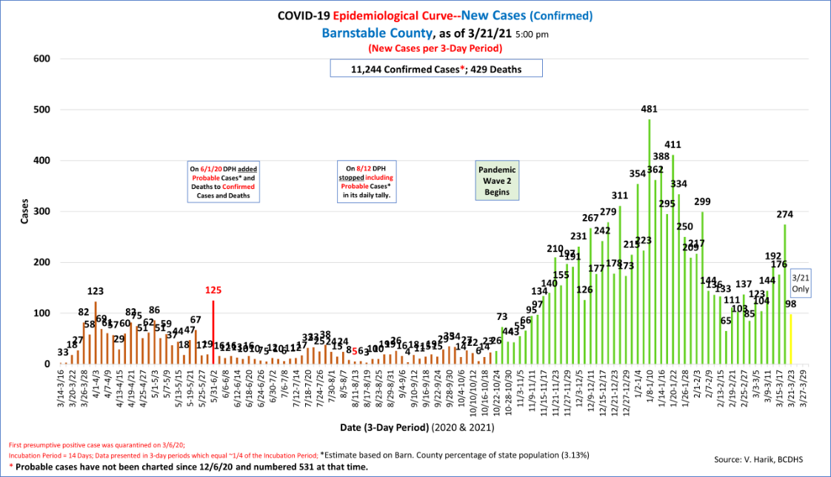

**Nantucket's**7-day average cases per 100,000 population (now **24/100K**) has dropped since last week.  On average (7-day) Nantucket is now picking up **3**new cases per day.  **9 cases**were reported over the weekend (Friday to Sunday, inclusive).

**Martha's Vineyard's**7-day average cases per 100,000 population (**12/100K**) remains low but has increased.  On average Dukes County is gaining approximately **2** new cases per day.**2**cases were reported over the weekend (Friday to Sunday, inclusive).

**Trailing 14-Day Testing and Cases by County:**

In the context of adequate availability of testing and contact tracing, which our three counties appear to have achieved, **a test percent positivity rate below 5% suggests that an outbreak is on the way to containment**.  Rates below 3% and 1% are further important containment milestones.

**Test Positivity Rates (14-day, as of 3/17/21):**

**Barnstable County:                      4.12%**(vs. 3.22%)  (higher vs. previous fortnight)

**Dukes & Nantucket Counties:   2.32%**(vs. 1.53%)  (higher)

**2.  Hospitalizations and Fatalities**

**Hospitalizations**and **acuity of illness** have **decreased very significantly** since the double peaks of the Wave 2 surge seen in min-January and early February (corresponding Thanksgiving and Christmas holidays).  Cape Cod Hospital and Falmouth Hospital have **resumed limited visitation** of inpatients.

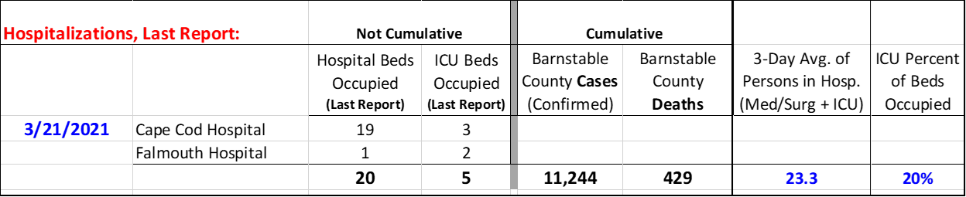

Since DPH reporting of hospitalizations has a 2-day lag Tina Shaw of CCHC is providing me with more recent information (thank you Tina).  Yesterday afternoon CCHC reported that there were **25** COVID **patients in hospital**, **5** of which were in the CCH **ICU.**

**Fatalities:  2** fatalities were reported over the weekend.  The total is **429.**

 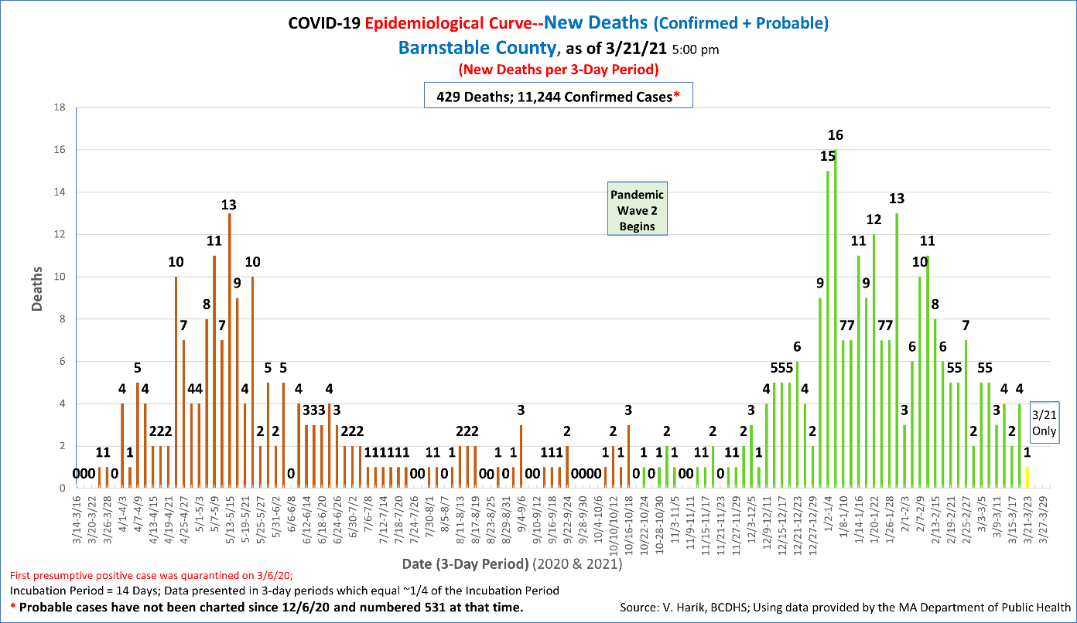

Recent data on COVID fatalities in Barnstable County suggest that residents of **Long Term Care/Skilled Nursing Facilities/Rest Homes**represent **42.5%** of all fatalities (167 of 393 fatalities, as of 2/25/21).  This is a **lower**percentage than that seen during phase 1 of the pandemic last spring (over 65%), and **this percentage continues to fall.  Indeed, between 1/5/21 and 2/23/21 only 20% of the County's 137 fatalities occurred among LTC residents.​**

This month marks the one-year **anniversary**of the recognition of the first COVID case in Massachusetts.​  In year 1 of this pandemic the **Barnstable County Case Fatality Rate (CFR) is 4%**, behind only Berkshire and Franklin Counties (which are also remote, rural locales), and is markedly higher than the **state CFR (2.8%)**.

**3.  Schools and Childcare Centers**

**School districts** are staying vigilant and reacting well to new cases. School districts on the Cape and Islands are in a hybrid learning status, **however DESE Commissioner Jeffrey Riley has announced plans which will compel schools to return to 100% in-person learning, starting with elementary schools, in April.  As such (and noted elsewhere), school and childcare teachers and staff became eligible for vaccinations on 3/11.**

DESE and the DPH (memo of 1/8/21) announced that they are seeking to introduce COVID-19 screening testing using a pooled strategy in the school setting.  Schools may elect to participate by responding to a survey that DESE/DPH have posted.  The status of this initiative is unclear at this time.

~~For the 2020-2021 school year the DPH has mandated that all school children be vaccinated for seasonal influenza.  This week the DPH extended the deadline for doing so from 12/31/20 to 2/28/21.~~ **This mandate has been canceled by the DPH.**

  **4.  Testing**

Additional testing locations in Barnstable Countyfor both symptomatic and asymptomatic persons remain open in **Falmouth**at the Fairgrounds and in **Hyannis**at Cape Cod Hospital (the Melody Tent site has been given over to vaccination clinics).  Daily testing capacity is 50 at the Falmouth site and 350 at the Hyannis site.  Neither site is open daily and persons must call ahead for an appointment.  Details: <https://www.capecodhealth.org/medical-services/infectious-disease/coronavirus/covid-19-testing-process/>. In late December additional testing by **Outer Cape Community Health Services**began and continues at its 3 locations in Wellfleet, Harwich Port, and Provincetown(<https://outercape.org/2020/12/23/outer-cape-health-services-to-offer-covid-19-asymptomatic-testing-beginning-december-23/>).  The **Community Health Center of Cape Cod** is also offering testing at its locations.  These sites may not open be daily and persons must call ahead for an appointment.

Eligibility criteria for the testing include residency in Barnstable County.  Testing is done by appointment only.  Tests cost $75, $110 for travel-related tests, and no one will be turned away if unable to pay for a test.   
  
DPH-mandated **routine testing** in skilled nursing facilities/long term care settings (SNF/LTC) continues.  This provides critical surveillance and allows these facilities to stay ahead of asymptomatic spread amongst staff and residents. Routine testing in SNF/LTC settings is conducted weekly for staff.

In addition, the State's **BinaxNOW rapid testing program** (available to **schools**) has been extended to visitors of **nursing homes**and rest home residents (LTC settings) to allow visitation of residents while limiting the risk of infection from visitors.  DPH has published guidance on this.  The program has also been extended to **homeless shelters**and management of these facilities may apply to the EEC and DPH for testing kits.

**5.  Weekly Town Risk and Statewide Cluster Analyses**

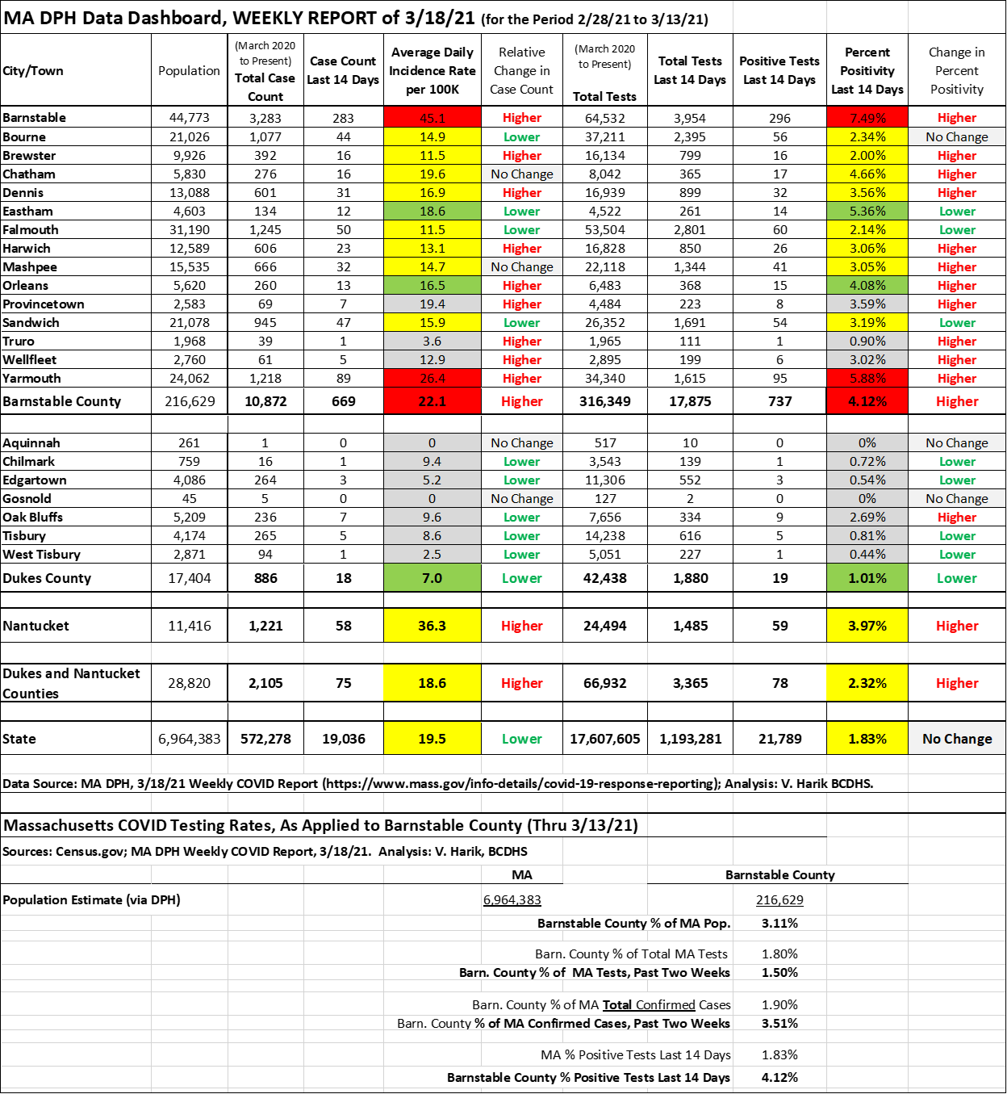

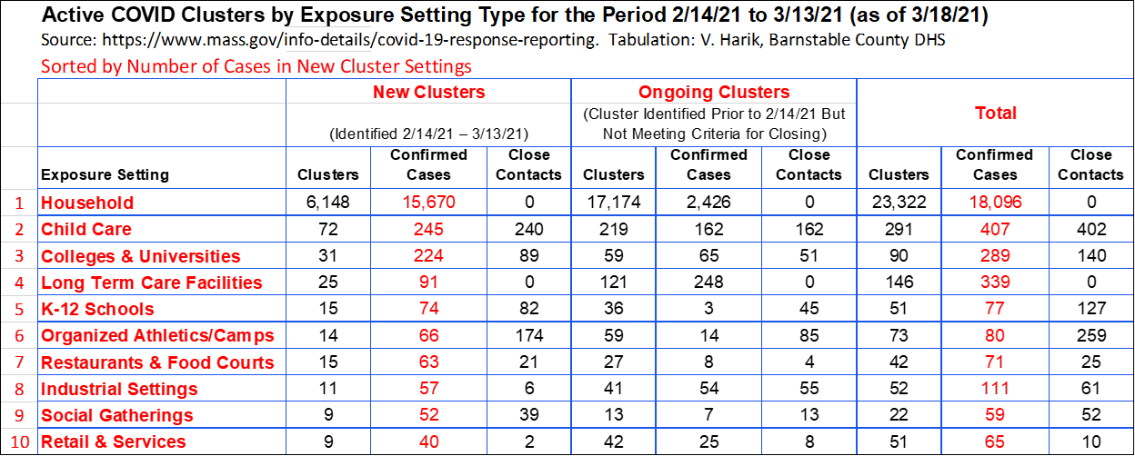

**6.  Vaccination**

​**Groups eligible for vaccination now are those in Phase 1, Phase 2/Group 1 (persons** **aged 75+), and Phase 2/Group 2 (65+, 2+ comorbidities, and residents and staff of low-income senior housing) depending upon availability of vaccine.**

**Caregivers**(regardless of age) **accompanying a 75+ person to their vaccination appointment** remain eligible for vaccination and can receive vaccination under these circumstances at DPH mass vaccination sites.  Local vaccination clinics may also allow this, but most are not doing so because of constrained vaccine supplies.

**​**​-Phase 2 of the State Vaccination Plan began on February 1.  **On March 11th K-12 teachers and staff and childcare teachers and staff became eligible for vaccination.**

The DPH has released the timeline by which all remaining groups will become eligible for vaccination:

**Timeline for remaining groups:**

March 22nd : Residents 60+ and certain workers (see <https://www.mass.gov/info-details/covid-19-vaccinations-for-certain-workers>)

April 5th :       Residents 55+ and residents with one certain medical condition

April 19th:      General public ages 16 years of age and older

**3/19/21: Barnstable County and Regional COVID-19 Daily Update**

(N.B.  I am no longer attempting to tally new probable cases alongside new confirmed cases.  I have not received information on probable cases since 12/6/20, at which time Barnstable County had logged a total of 531.)

**Good Morning All.**

**MA Vaccination Eligibility Timeline for all remaining groups has been released​**: The DPH has released the timeline by which all remaining groups will become eligible for vaccination:

**Timeline for remaining groups:**

March 22nd : Residents 60+ and certain workers (see <https://www.mass.gov/info-details/covid-19-vaccinations-for-certain-workers>, and the table below)

April 5th :       Residents 55+ and residents with one certain medical condition

April 19th:      General public ages 16 years of age and older

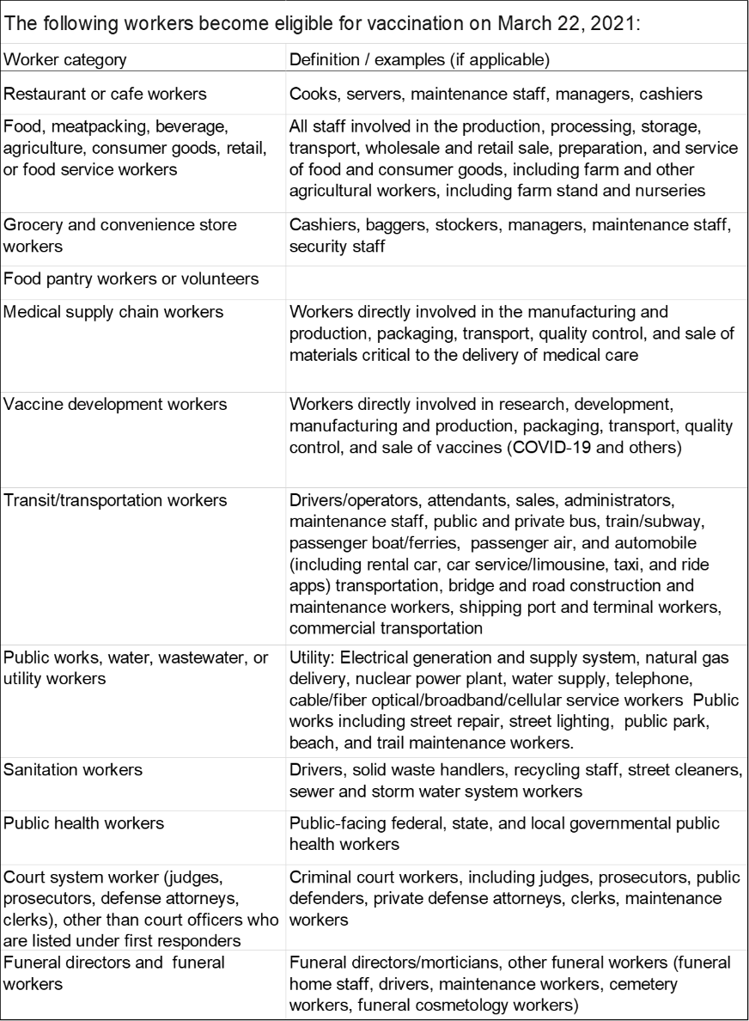

**The first case of the Brazilian variant P1 has been announced in Massachusetts in Barnstable County** (30 year-old female)**.**

**SUMMARY:**

**1.  New Cases:**DPH new cases reported yesterday:

**Barnstable County:        82** new cases (cases continue climb--mid-Cape sub-region)

**Martha's Vineyard:          5**new cases  
**Nantucket:                         3** new cases (cases continue to climb)  
  
 **2.  Hospitalizations and Fatalities:**3-day avg. hospitalizations (now **19**) remain in the 'teens (they were in the mid-60s in January during the post-holiday surge).  ICU patient numbers have been stable, between **2 to 5** patients per day (in CCH).  There were**3 COVID fatalities** reported yesterday.  CCH and Falmouth Hospital have re-opened to limited visitation.

The first week of March marked the **one-year anniversary** of the recognition of the first COVID case in Massachusetts.​  In year 1 of this pandemic the **Barnstable County Case Fatality Rate (CFR) is 4%**, behind only Berkshire and Franklin Counties (which are also remote, rural locales), and is markedly higher than the **state CFR (2.8%)**.

Recent data on COVID fatalities in Barnstable County suggest that residents of **Long Term Care/Skilled Nursing Facilities/Rest Homes**represent **42.5%** of all fatalities (167 of 393 fatalities, as of 2/23/21).  This is a **lower**percentage than that seen during phase 1 of the pandemic last spring (over 65%), and **this percentage continues to fall.  Indeed, between 1/5/21 and 2/23/21 only 20% (28) of 137 fatalities occurred among LTC residents.**  
  
**3.  Schools and Childcare Centers:**Due to the mildness of the flu season the DPH has **removed the requirement** that all school children receive a flu vaccination on or before 2/28/21.  **School districts remain in a hybrid learning model.**  However, **DESE Commissioner Jeffrey Riley has announced plans which will compel schools to return to 100% in-person learning, starting with elementary schools, in April.**

**4.  Testing; Test Positivity Rates**(14-day, as of 3/17/21)**:**

**Barnstable County:                     4.12%** (vs. 3.22%)  (higher vs. previous fortnight)

**Dukes & Nantucket Counties:   2.32%** (vs. 1.53%)  (higher)

        A test percent positivity rate below 5% suggests that an outbreak is on the way to **containment**.

**5.  Weekly Town Risk, and Statewide Cluster Analyses**:  See charts below (analysis of 3/11/21 data is pending).

**6.  Vaccination:**

​     -Groups eligible for vaccination now are those in Phase 1, and Phase 2/Group 1 (persons aged 75+), and Phase 2/Group 2 (65+, 2+ comorbidities, residents and staff of low-income senior housing), and (effective 3/11) Phase 2/Group 3 --K-12 and early education/childcare teachers and staff, **depending upon availability of vaccine.**

 ​    -Caregivers (regardless of age) accompanying a 75+ person to their vaccination appointment remain eligible for vaccination and can receive vaccination under these circumstances at **DPH mass vaccination sites**.  Local vaccination clinics may also allow this, but most are not doing so because of constrained vaccine supplies.

**​**​-Phase 2 of the State Vaccination Plan began on February 1.  **On March 11th K-12 teachers and staff and childcare teachers and staff became eligible for vaccination.**

     -Vaccination at local clinics during Phase 2 are by appointment only and **appointments are announced and able to be scheduled once County and local health authorities are sure of vaccine availability from the DPH**.  The public is being given notice of planned vaccination clinics for eligible persons in Phase 2.

    -Plans for 4-5 sub-regional mass vaccination sites on Cape Cod, for operation during Phase 2, are in place.  A **Cape Cod Regional Vaccine Consortium** has been established via a partnership between the Barnstable County Health Dept, Local Town Boards of Health (LBOHs), Community Health Centers (CHCs), and Cape Cod Healthcare, and has received support from the DPH.  The Consortium has established a **vaccination site at Cape Cod Community College** (which opened this week) and is also working with LBOHs and CHC to **organize in-reach to homebound persons** to vaccinate them.  **The DPH is responsible for providing sufficient vaccine in order for the Consortium to reach its full potential.**

     -**The DPH has begun reporting vaccination progress age group and by town**.  Below is a summary table for Barnstable County by age group.

**7.  COVID Mutation** and Changes in Transmissibility/Virulence/Other:  **There are four variants of concern: B117 (UK), B1351 (S. Africa), P1 (Brazil), and B1526 (New York City,**which emerged in November).  All four appear to be significantly more transmissible than the virus which dominated Wave 1 of the pandemic. Within two months of the B117 variant being identified in the UK (October) it became the dominant strain circulating there.  The CDC is now posting surveillance information on the emergence of the B117 variant in the US:  <https://www.cdc.gov/coronavirus/2019-ncov/transmission/variant-cases.html>.​   Existing vaccines may be less effective against these new strains.  The degree to which this may be so is being investigated.  Moderna and Pfizer are working on a booster shot to counter these new strains.

     -B1526 now accounts for 40% of new cases in NYC

**-B117 and B1351 have been identified in Massachusetts.**

**-The first case of the Brazilian variant P1 has been announced in Massachusetts in Barnstable County.**

**REPORT DETAIL:**

**1.  New Cases**

Daily new case numbers in Barnstable County are moving upward again, following a major decline since the holiday season surge. **192 cases**were reported over the weekend (Friday to Sunday, inclusive), a further 176 caseswere reported Monday-Wednesday, and 82 cases were reported yesterday.  **The case increases are most prominent in the mid-Cape region**.  The 7-day average new cases per 100,000 has increased to **30/100K**, with Barnstable County acquiring an **average of 64 cases per day over the past 7 days**.

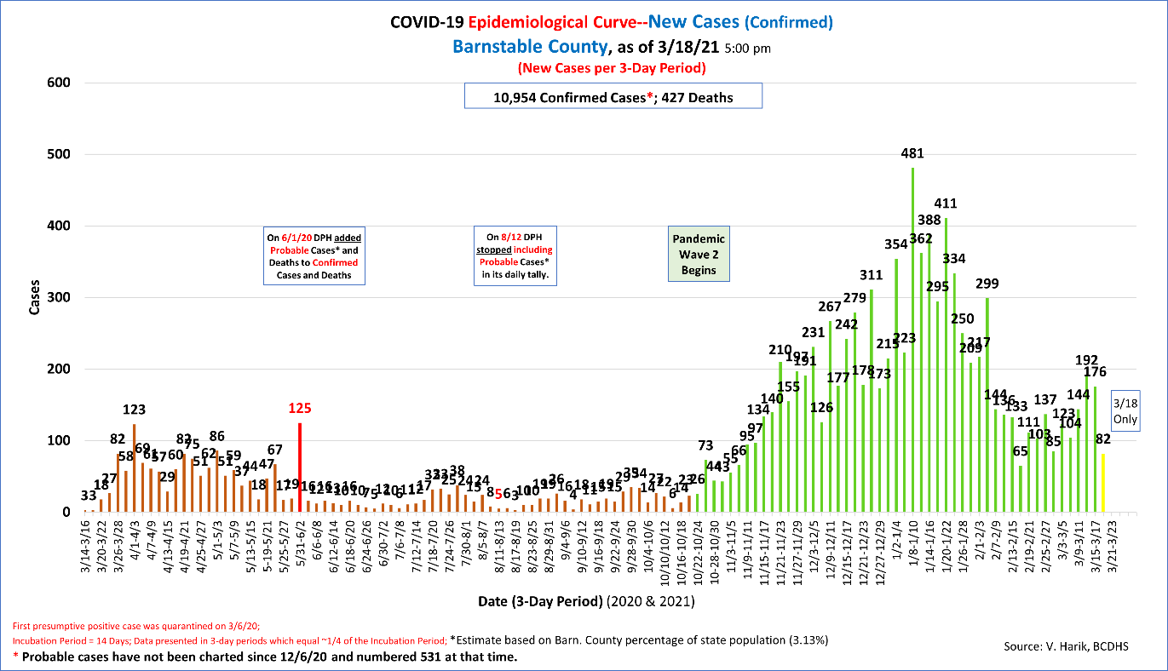

**Nantucket's**7-day average cases per 100,000 population (now **45/100K**) remains high.  On average (7-day) Nantucket is now picking up **5**new cases per day.  **26 cases**were reported over the weekend (Friday to Sunday, inclusive), **7** new cases were reported yesterday.

**Martha's Vineyard's**7-day average cases per 100,000 population (**4/100K**) remains very low.  On average Dukes County is gaining approximately **1.4** new cases per day.**5** cases were reported yesterday.

**Trailing 14-Day Testing and Cases by County:**

In the context of adequate availability of testing and contact tracing, which our three counties appear to have achieved, **a test percent positivity rate below 5% suggests that an outbreak is on the way to containment**.  Rates below 3% and 1% are further important containment milestones.

**Test Positivity Rates (14-day, as of 3/17/21):**

**Barnstable County:                      4.12%**(vs. 3.22%)  (higher vs. previous fortnight)

**Dukes & Nantucket Counties:   2.32%**(vs. 1.53%)  (higher)

**2.  Hospitalizations and Fatalities**

**Hospitalizations**and **acuity of illness** have **decreased very significantly** since the double peaks of the Wave 2 surge seen in min-January and early February (corresponding Thanksgiving and Christmas holidays).  Cape Cod Hospital and Falmouth Hospital have **resumed limited visitation** of inpatients.

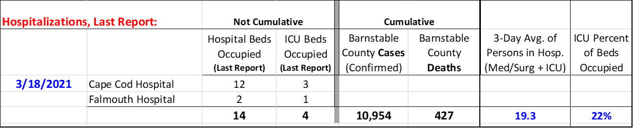

Since DPH reporting of hospitalizations has a 2-day lag Tina Shaw of CCHC is providing me with more recent information (thank you Tina).  Yesterday afternoon CCHC reported that there were **18** COVID **patients in hospital**, **4** of which were in the CCH **ICU.**

**Fatalities:  3** fatalities were reported yesterday.  The total is **427.**

 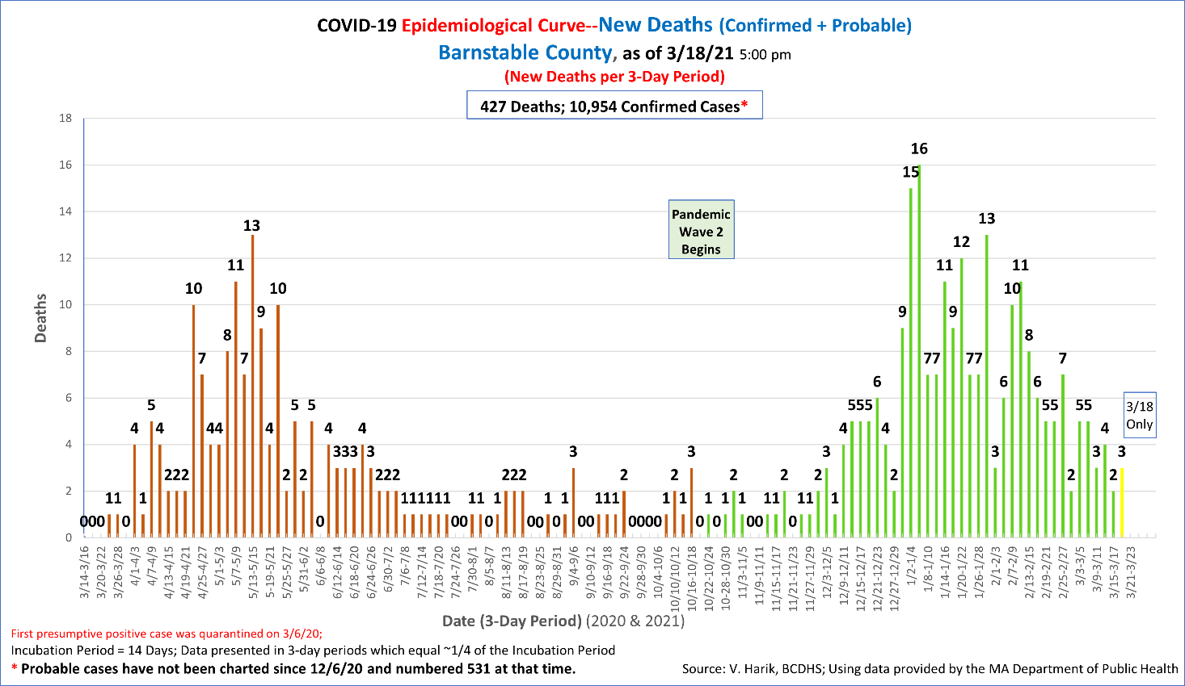

Recent data on COVID fatalities in Barnstable County suggest that residents of **Long Term Care/Skilled Nursing Facilities/Rest Homes**represent **42.5%** of all fatalities (167 of 393 fatalities, as of 2/25/21).  This is a **lower**percentage than that seen during phase 1 of the pandemic last spring (over 65%), and **this percentage continues to fall.  Indeed, between 1/5/21 and 2/23/21 only 20% of the County's 137 fatalities occurred among LTC residents.​**

This month marks the one-year **anniversary**of the recognition of the first COVID case in Massachusetts.​  In year 1 of this pandemic the **Barnstable County Case Fatality Rate (CFR) is 4%**, behind only Berkshire and Franklin Counties (which are also remote, rural locales), and is markedly higher than the **state CFR (2.8%)**.

**3.  Schools and Childcare Centers**

**School districts** are staying vigilant and reacting well to new cases. School districts on the Cape and Islands are in a hybrid learning status, **however DESE Commissioner Jeffrey Riley has announced plans which will compel schools to return to 100% in-person learning, starting with elementary schools, in April.  As such (and noted elsewhere), school and childcare teachers and staff became eligible for vaccinations last week (3/11).**

DESE and the DPH (memo of 1/8/21) announced that they are seeking to introduce COVID-19 screening testing using a pooled strategy in the school setting.  Schools may elect to participate by responding to a survey that DESE/DPH have posted.  The status of this initiative is unclear at this time.

~~For the 2020-2021 school year the DPH has mandated that all school children be vaccinated for seasonal influenza.  This week the DPH extended the deadline for doing so from 12/31/20 to 2/28/21.~~ This mandate has been canceled by the DPH.

  **4.  Testing**

Additional testing locations in Barnstable Countyfor both symptomatic and asymptomatic persons remain open in **Falmouth**at the Fairgrounds and in **Hyannis**at Cape Cod Hospital (the Melody Tent site has been given over to vaccination clinics).  Daily testing capacity is 50 at the Falmouth site and 350 at the Hyannis site.  Neither site is open daily and persons must call ahead for an appointment.  Details: <https://www.capecodhealth.org/medical-services/infectious-disease/coronavirus/covid-19-testing-process/>. In late December additional testing by **Outer Cape Community Health Services**began and continues at its 3 locations in Wellfleet, Harwich Port, and Provincetown(<https://outercape.org/2020/12/23/outer-cape-health-services-to-offer-covid-19-asymptomatic-testing-beginning-december-23/>).  The **Community Health Center of Cape Cod** is also offering testing at its locations.  These sites may not open be daily and persons must call ahead for an appointment.

Eligibility criteria for the testing include residency in Barnstable County.  Testing is done by appointment only.  Tests cost $75, $110 for travel-related tests, and no one will be turned away if unable to pay for a test.   
  
DPH-mandated **routine testing** in skilled nursing facilities/long term care settings (SNF/LTC) continues.  This provides critical surveillance and allows these facilities to stay ahead of asymptomatic spread amongst staff and residents. Routine testing in SNF/LTC settings is conducted weekly for staff.

In addition, the State's **BinaxNOW rapid testing program** (available to **schools**) has been extended to visitors of **nursing homes**and rest home residents (LTC settings) to allow visitation of residents while limiting the risk of infection from visitors.  DPH has published guidance on this.  The program has also been extended to **~~childcare centers~~**(?  Checking...)**and homeless shelters**and management of these facilities may apply to the EEC and DPH for testing kits.

**5.  Weekly Town Risk and Statewide Cluster Analyses**   **(3/17/21 Update in process)**

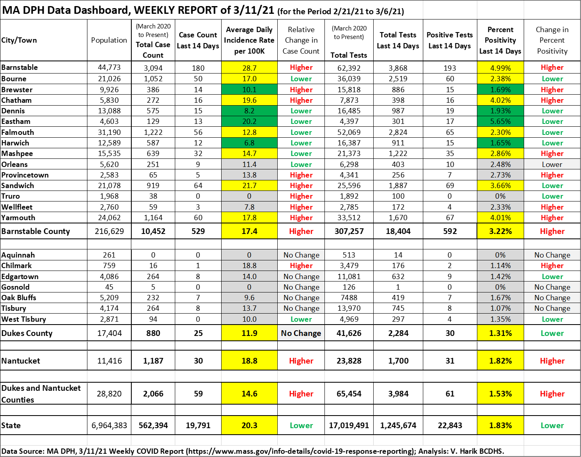

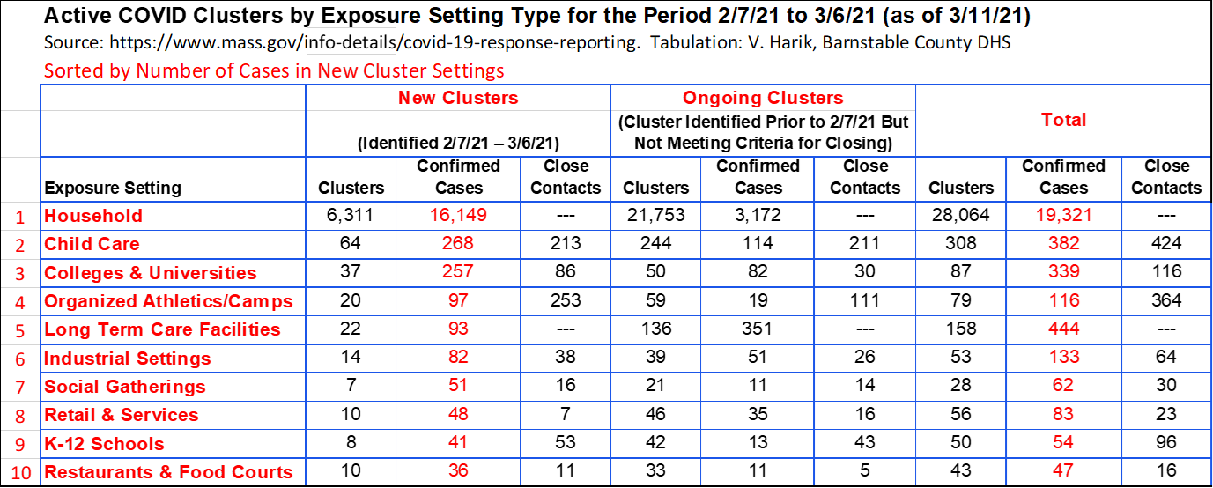

**6.  Vaccination**

​**Groups eligible for vaccination now are those in Phase 1, Phase 2/Group 1 (persons** **aged 75+), and Phase 2/Group 2 (65+, 2+ comorbidities, and residents and staff of low-income senior housing) depending upon availability of vaccine.**

**Caregivers**(regardless of age) **accompanying a 75+ person to their vaccination appointment** remain eligible for vaccination and can receive vaccination under these circumstances at DPH mass vaccination sites.  Local vaccination clinics may also allow this, but most are not doing so because of constrained vaccine supplies.

**​**​-Phase 2 of the State Vaccination Plan began on February 1.  **On March 11th K-12 teachers and staff and childcare teachers and staff became eligible for vaccination.**

The DPH has released the timeline by which all remaining groups will become eligible for vaccination:

**Timeline for remaining groups:**

March 22nd : Residents 60+ and certain workers (see <https://www.mass.gov/info-details/covid-19-vaccinations-for-certain-workers>)

April 5th :       Residents 55+ and residents with one certain medical condition

April 19th:      General public ages 16 years of age and older

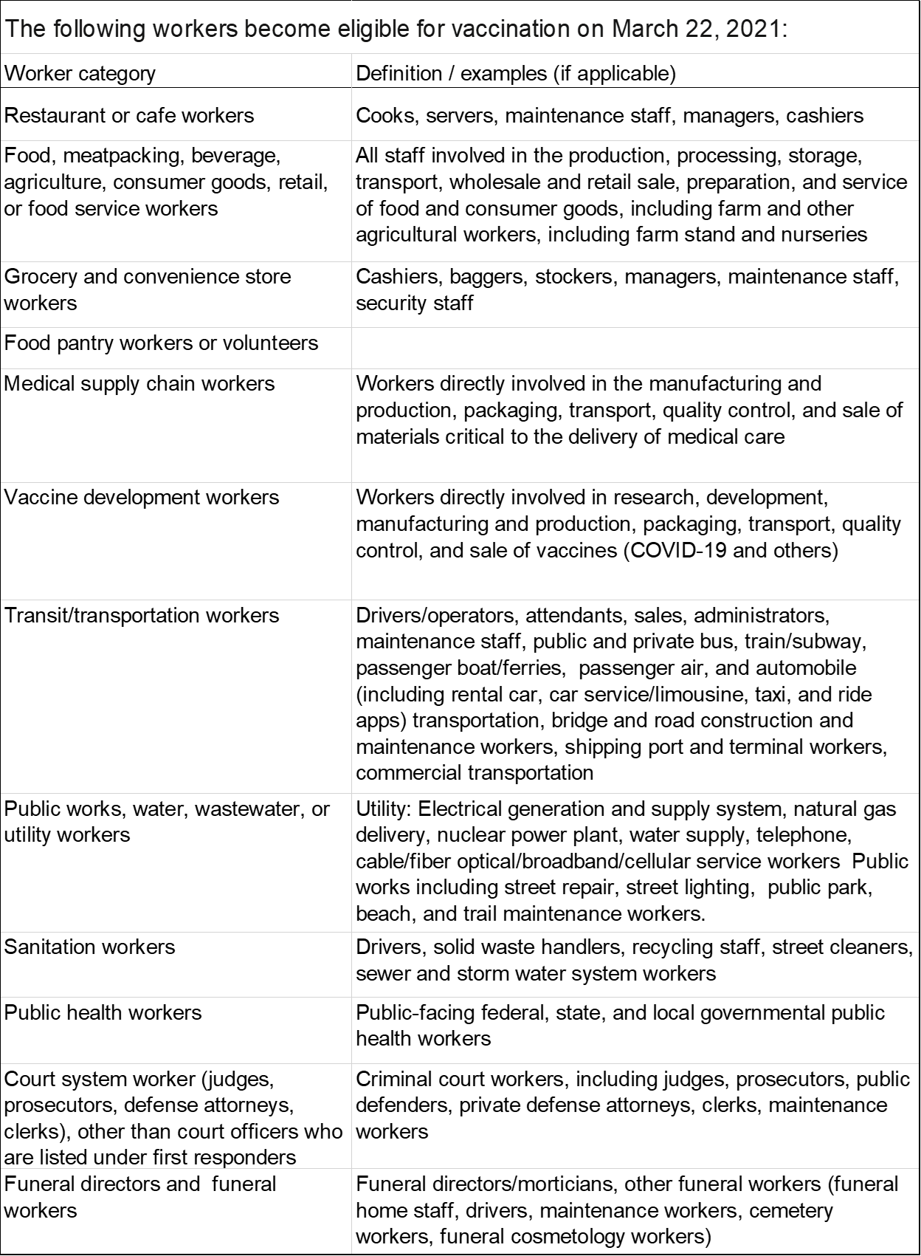

Vaccination at local clinics during Phase 2 is by appointment only and **appointments are announced and able to be scheduled once County and local health authorities are sure of vaccine availability from the DPH**.  The public is being given notice of planned vaccination clinics for eligible persons in Phase 2.

**Appointments (**<https://www.cic-health.com/vaccines-location>**)**may not be immediately available due to overwhelming demand and still-limited supply of vaccine from the manufacturers.  **Appointments for local vaccination clinics are only being scheduled once County and local health authorities can be sure of vaccine availability from the DPH**.  The public is being given notice of planned vaccination clinics for eligible persons in Phase 2.

Vaccination is available at several **State-run mass vaccination sites**around Massachusetts.  The closest ones to Cape Cod are at **Gillette Stadium in Foxboro and in Dartmouth**.  Appointments can be scheduled by visiting <https://www.cic-health.com/vaccines-location>, or calling **2-1-1** and following the prompts if the citizen does not have access to/or cannot operate on the internet. 

-Plans for 4-5 sub-regional mass vaccination sites on Cape Cod, for operation during Phase 2, are in place.  A **Cape Cod Regional Vaccine Consortium** has been established via a partnership between the Barnstable County Health Dept, Local Town Boards of Health (LBOHs), Community Health Centers (CHCs), and Cape Cod Healthcare, and has received support from the DPH.  The Consortium has established a **vaccination site at Cape Cod Community College** and is also working with LBOHs and CHC to **organize in-reach to homebound persons** to vaccinate them.  **The DPH is responsible for providing sufficient vaccine in order for the Consortium to reach its full potential.**

**Harbor Health Services, Inc. (Hyannis)** will join the other three Federally Qualified Community Health Centers on Cape Cod in offering **vaccination clinics.**

The State has contracted with **CVS and Walgreens**to arrange vaccination of **older adults in SNFs/congregate care.  CVS, Walgreens, and Stop & Shop pharmacies** are also scheduling vaccinations for the groups in Phase 2, again depending upon vaccine supply.

**The DPH has begun reporting vaccination progress age group and by town**.  Below is a summary for Barnstable County by age group **(3/17 update in process)**

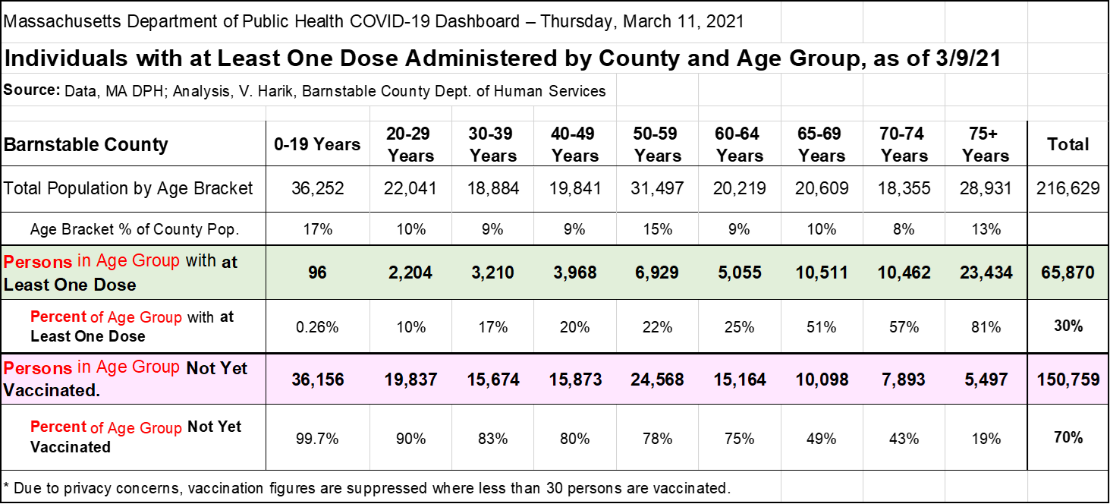

**7.  COVID Mutation and Changes in Transmissibility/Virulence/Other**

**The emergence of a variant of the COVID-19 virus in the UK**, classified as **B.1.1.7**, was identified in September and publicized in early December.  Reports hold that B117 is 50% - 70% more contagious than our predominant variant now circulating (D614G).  Within three months of the variant being identified in the UK it became dominant strain circulating there.  Additional variants of concern have emerged internationally: **B1351** (South Africa) and Brazil (**P1**) which are also highly transmissible. **An additional variant, B1526,  emerged in New York City in November.  Its features are being studied.**

All variants appear to be significantly more transmissible than the virus which dominated Wave 1 of the pandemic.

**The first three variants are spreading globally and have been detected in the US.**

**The B117 and B1351 variants have been identified by the DPH as being in circulation in MA.​**

**The B1526 (NYC) variant now accounts for 40% of new cases in New York City.**

Researchers are working to determine if the variants differ from D614G (the Wave 1 configuration) in terms of: **1.**How sick people become, **2.**If natural immunity is different following infection with D614G, and **3.**If immunity from vaccination differs since the vaccine was developed during the period that D614G has been predominant.  **The existing vaccines may be less effective against the new strains.  Moderna and Pfizer are working on booster shots to counter these new strains.**

The CDC is posting surveillance information on the emergence of the variants in the US:  <https://www.cdc.gov/coronavirus/2019-ncov/transmission/variant-cases.html>.

According to an article by Andrew Joseph from StatNews, "Coronaviruses evolve more slowly than viruses like flu, but they do pick up mutations as they spread.  **SARS-CoV-2 has been adding one or two changes a month to its RNA genome since it emerged late last year in China**, and different versions of the virus have been continuously circulating throughout the course of the pandemic.But this variant (B.1.1.7 or VUI-202012/01) showed up with at least 17 mutations,according to one genetic analysis." (Source: <https://www.statnews.com/2020/12/21/looming-questions-new-variant-coronavirus/?utm_source=STAT+Newsletters&utm_campaign=1a74bda2ca-MR_COPY_01&utm_medium=email&utm_term=0_8cab1d7961-1a74bda2ca-150158417> ).

 ______________________

**Vaira Harik**, M.S.

Deputy Director

Barnstable County Dept. of Human Services

**Cell:**520-271-6314

**Email**:  [vharik@barnstablecounty.org](mailto:vharik@barnstablecounty.org)