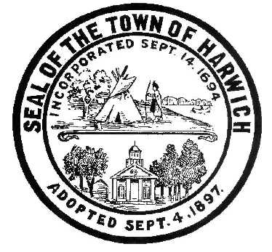**Town of Harwich**

**Board of Health**

732 Main Street Harwich, MA 02645

508-430-7509 – Fax 508-430-7531

E-mail: health@town.harwich.ma.us

**Weekly COVID-19 Update** *(April 2, 2021)*

***CASES & STATISTICS***

To date, Harwich has seen a cumulative total of 665 cases of COVID-19. We are currently following 56 active cases. The positivity rate has increased to 5.63%, which still leaves us in the “Red” designation. Over the last two weeks, the Town has seen 62 positive cases out of 1102 total tests. The Average age of recent cases to date is approximately 42 years old, compared to all of Barnstable County, which is 38 years old.

|  |  |
| --- | --- |
| Town | Average Age of Positive Cases (“Red Towns) |
| BARNSTABLE | 36 |
| BREWSTER | 48 |
| DENNIS | 45 |
| HARWICH | 42 |
| MASHPEE | 38 |
| SANDWICH | 35 |
| YARMOUTH | 41 |
| Average | **38** |

***VACCINE***

|  |  |  |  |  |
| --- | --- | --- | --- | --- |
| **Age Group** | **Population** | **Individuals with at least one dose** | **Fully vaccinated individuals** | **Partially vaccinated individuals** |
| 0-19 Years | 1,993 | 32 | 0 | 0 |
| 20-29 Years | 1,055 | 196 | 99 | 97 |
| 30-49 Years | 2,146 | 724 | 387 | 337 |
| 50-64 Years | 3,012 | 1,302 | 589 | 713 |
| 65-74 Years | 2,551 | 1,977 | 1,271 | 706 |
| 75+ Years | 1,833 | 1,694 | 1,409 | 285 |
| **Total** | **12,589** | **5,925** | **3,755** | **2,138** |

A total of 3,755 full time Harwich residents have been fully vaccinated, and 5,925 individuals have received at least one dose.

On Tuesday March 30th, the Harwich Fire Department, in collaboration with Outer Cape Health, Harwich Council on Aging, and the Harwich Health Department, vaccinated 42 individuals in Senior Housing. On Monday April 5th, an additional 55 homebound individuals will also be vaccinated. A special thank you to Outer Cape Health, Emily Mitchell, Sue Jusell, Jen Clarke, Chief LeBlanc, Deputy Chief Thorton, Paul Finn, and all of Harwich EMS for assisting in this collaborative effort. If anyone knows of a homebound individual still in need of vaccination, please contact either the Harwich Health Department at (508)-430-7509, or the Council on Aging at (508)-430-7550. This will be a continued effort to ensure that all who need to be vaccinated will be.

Starting Monday Aril 5th, people who are 55 and older will be eligible to receive the vaccine, as well as people with 1 certain medical condition.

Pre-register to receive a vaccination at <https://www.mass.gov/info-details/preregister-for-a-covid-19-vaccine-appointment>. Currently eligible participants can sign up for a vaccine at <https://vaxfinder.mass.gov/>.

***TESTING***

For testing options at Outer Cape Health, please call [508-905-2888](tel:+1-508-905-2888) in advance to make a testing appointment.

Testing is available in other locations 7 days per week through Cape Cod Healthcare. Call the Community Testing Line at 508-534-7103 to make an appointment.

***REMINDER***

Please continue to maintain social distancing, mask use, and good hand hygiene. We need to work together as a community to minimize the spread!

Stay Safe!

~Dr. Katie O’Neill

*Health Director*

**Barnstable County Health Department COVID Mini-Update: 3/31/21**

