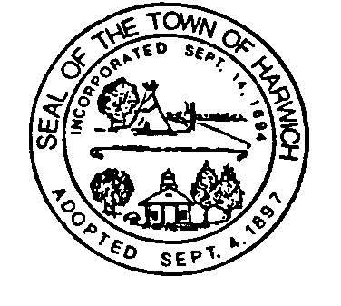TOWN OF HARWICH PLANNING DEPARTMENT

MEMO Date: March 28, 2024
To: Emily Mitchell, Town Clerk
From: Shelagh Delaney, Planning Assistant
RE: PB2024-10 Donald and Mary Gould; 144 Church Street & 7 Sparrowhawk Rd.
Deed Book 1051, Page 184/Deed Book 22059, Page 125
Plan Book 591, Page 26

Approval Not Required (ANR)

You are hereby notified that at its meeting on Tuesday, March 26, 2024, the Planning Board endorsed the Approval Not Required (ANR) plan entitled “Plan of Land in Harwich MA #144 Church Street & #7 Sparrowhawk Road prepared for Donald S. & Mary V. Gould and Seth Edward Harry Gould by Outermost Land Survey, Inc. dated January 29, 2024 (“the Plan”) by a vote of 6-0-0.
Specifically, the Board found that the Plan does not depict a subdivision and thus does not require approval under subdivision control law. (MGL 41 §§ 81L and 81P and Subdivision Rules and Regulations of the Code of the Town of Harwich).
The subject land is in the RR zoning district and is currently identified as map 88, parcels T1-11 and T1-12, 144 Church Street and 7 Sparrowhawk Road.

Cc: Donald Pool
Carlene Jones, Harwich Assessor
Building Department
File

