TOWN OF HARWICH
WATERWAYS COMMITTEE
Harwich Fire House Conference Room
Wednesday January 15, 2020
6:00 PM
MINUTES
Call to Order: 6:12 pm
Members Present: Matt Hart, Chairman; Roger Peterson; Steve Root; Tom Themistos;
Members Absent: Mort Terry, Joe Johnson; Dan Casey; Dan Hall; Jay Walpole
Others Present: John Rendon, Harbormaster; Heinz Proft, Natural Resources Director;

MINUTES: Motion made by Steve Root to Approve the Minutes for December 18, 2019. Seconded by Tom Themistos. All members were unanimous.

FINANCIAL REPORT YTD & MONTHLY:
Presented by Steve Root and Harbormaster Rendon
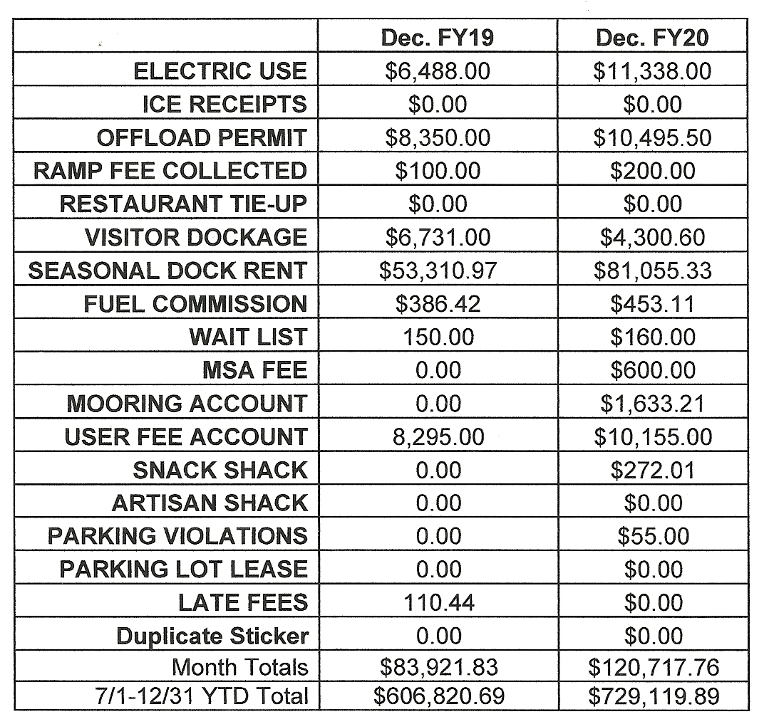
NEW BUSINESS:
- Letter from Amy Usowski, Conservation Administrator. A motion was made by Tom Themistos in reference to Chapter 304 Water Dependent Structures in reviewing the proposed information presented to the WWC on January 15, 2020, does not provide enough time for the committee to review the proposed changes. The Waterway Committee needs additional information and time to express a position on these proposed changes. Seconded by Steve Root all members were unanimous.
OLD BUSINESS: none this month

MONTHLY REPORTS:

Board of Selectmen nothing this month
Harbormaster- nothing this month
Natural Resource Officer nothing this month

CORRESPONDANCE: None this month

NEXT MEETING: Wednesday, February 19, 2020

ADJOURNMENT: Motion by Tom Themistos to adjourn at 7:00PM, seconded by Steve Root. All members voting in favor.

Minutes recorded by Leah McPherson

Chairman: W. Matt Hart Date: 02/04/ 2020
Signed:

