TOWN OF HARWICH
WATERWAYS COMMITTEE
Harwich Fire House Conference Room
Wednesday , March 20 , 2019
6:00 PM
MINUTES

The March 2019 Meeting was postponed until April 17, 2019

Chairman: W. Matt Hart Date: 12, 2019
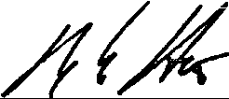
Signed:

