TOWN OF HARWICH
WATERWAYS COMMITTEE
Harwich Fire House Conference Room
Wednesday September 18, 2019
6:00 PM
Call to Order: 6:00pm

Members Present: Matt Hart, Chairman; Mort Terry, Vice Chairman; Roger Peterson; Steve Root; Joe Johnson; Dan Casey; Dan Hall Members Absent: Tom Themistos; Jay Walpole.

Others Present: John Rendon, Harbormaster; Heinz Proft, Natural Resources Director; Fred Clancy, Honorary WWC , Guest: Don, from Coastal Engineering Co

MINUTES: Motion made by Mort Terry to Approve the Minutes for May 15, 2019 and June 19, 2019, Seconded by Joe Johnson. All members were unanimous.
There was no WWC meeting in July 2019.
Motion made by Mort Terry to approve the minutes for August 21, 2019, Seconded by Steve Root. All members were unanimous.

FINANCIAL REPORT YTD & MONTHLY:
Presented by Steve Root and Harbormaster Rendon
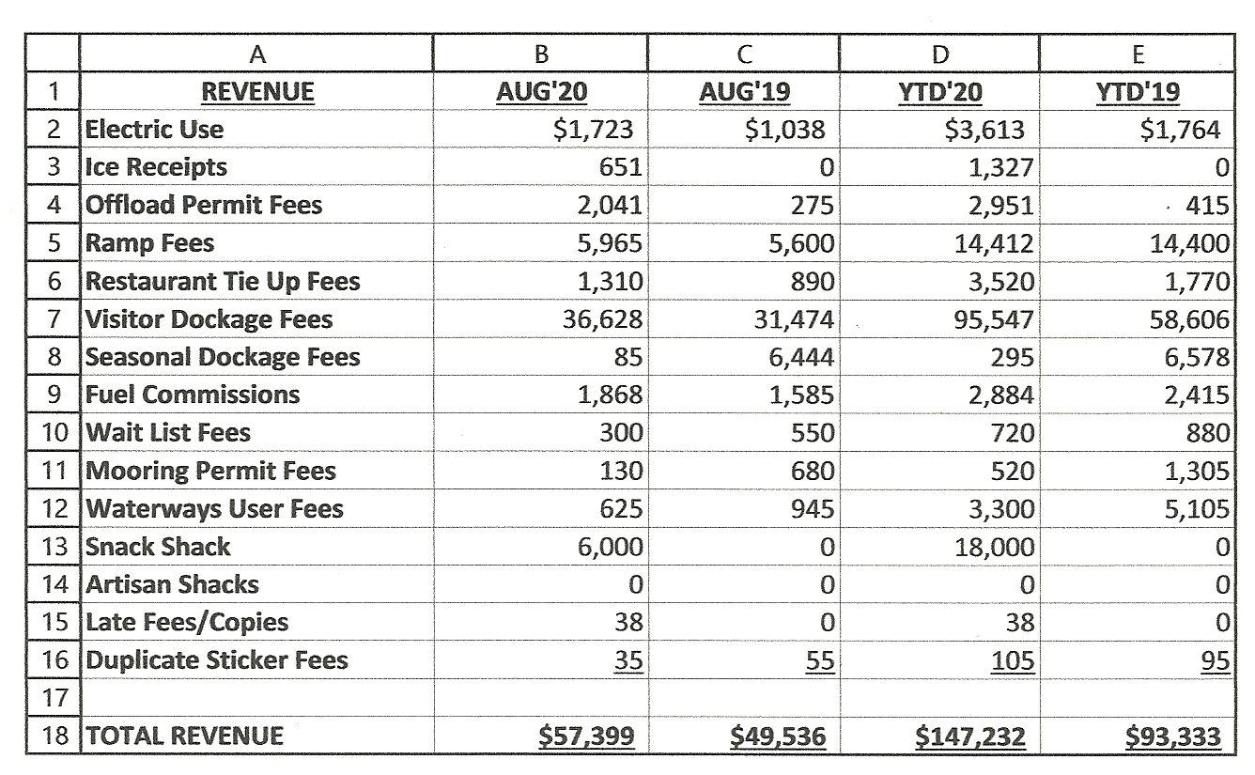

NEW BUSINESS:
Coastal Engineering Co. Groin Reconstruction and Beach Nourishment 6, 10, & 12
Neel Road. Motion made by Joe Johnson that “Waterways Committee has no objections to what is being proposed,” seconded by Steve Root. All members were unanimous

OLD BUSINESS: None this month

MONTHLY REPORTS:

Board of Selectmen: Nothing this month
Harbormaster- Harbormaster Rendon updated on projects ahead for next year
Natural Resource Officer: Nothing this month

CORRESPONDANCE: None this month

NEXT MEETING: Wednesday, October 16, 2019

ADJOURNMENT: Motion by Steve Root to adjourn at 6:55PM, seconded by Mort Terry. All members voting in favor.

ADJOURNMENT: Motion by Steve Root to adjourn at 6:55PM, seconded by Mort Terry. All members voting in favor.

Minutes recorded by Leah McPherson

Chairman: W. Matt Hart
Signed: September 20, 2019

